Quick Start Guide
FULL HD Wi-Fi OUTDOOR CAMERA
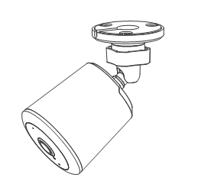

Model: E97V
KEYCODE: 42988281

Welcome, Thank you for choosing our smart camera, getting started is easy. What’s included
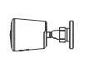 | 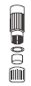 | 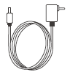
Security camera | Network Cable Waterproof kit | Power Adapter | Wall mount screw sets
Product Details
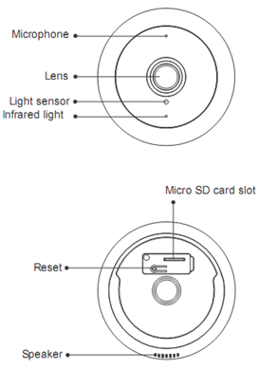

Connection Preparation
It is important that your phone is connect to 2.4Ghz Wi-Fi and not to the 5GHz network.
To verify your mobile device is set to a 2.4Ghz Wi-Fi network, navigate to the Settings menu and click on Wi-Fi. In this menu you will see all the detectable networks in your area. Locate the SSID (the name of your network), and ensure that the Wi-Fi SSID does not end with a 5G / 5GHz.
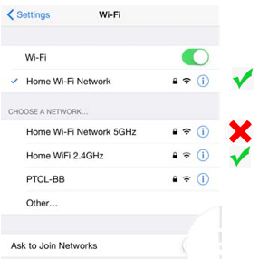
Check you have a strong WI-FI signal (at least two bars) in the location where the smart camera is to be installed. 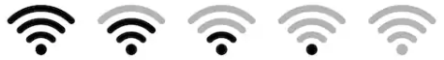
If you don’t have at least two bars signal on your phone, then you may need to reconsider the relocating the camera to a different location or obtain a Wi-Fi extender to boost the WI-FI signal strength.
Install the APP and register Account
For the best experience, download the "Mirabella Genio" APP to your smartphone from the App Store or Google Play, or you can also scan the QR code below, the Genio APP icon will be displayed after it has been installed successfully.
Insert the Micro SD card (Micro SD card not included)
The camera is able to work without a Micro SD card but it will not able to record any footage without a Micro SD card.
Remove the rubber plug from the back of the camera, and carefully insert the Micro SD card in the correct direction, do not force it inside. Then replace the rubber cover to ensure waterproofing.
Micro SD card size needs to be greater than 8GB, Supports up to Max of 128Gb.
.

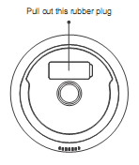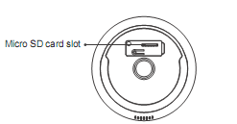

Pairing the camera using Mirabella Genio App
- Connect the power to the camera using the supplied DC 12V 1A power adapter then switch it on.
- Wait for 30-40 seconds, the indicator light will start blinking rapidly in RED (2 blinks per second) – The camera is now ready to pair.
- Launch the Mirabella Genio APP, then tap on “+” symbol, then choose Security & Sensor, and select your camera from the menu.
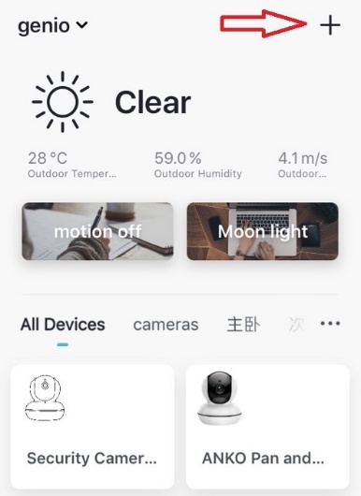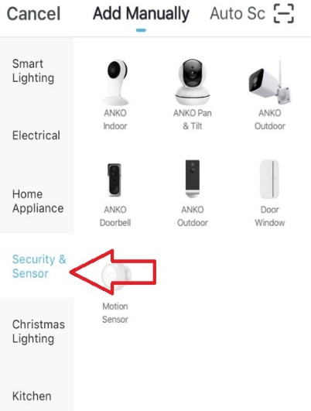
Follow the APP’s instruction carefully to complete the network pairing process.
Video instuctions are also avilable at www.mirabellagenio.com.au
If after scanning the QR code the indicator light changes from blinking Red to blinking Blue but fails to become a solid Blue, or if you have received a time out and/or device not found error, this is an indication of a communication error with the router,
Please ensure
- That you have manually disabled the 5Ghz WIFI signal on the router setting.
- Make sure you enter the correct 2.4Ghz Wi-Fi name and password
If the led indicator light is not red and blinking rapidly when turned on (2 blinks per second), power off the camera, wait for 10 sec, power on and hold the reset button until the light start to blinking red rapidly and repeat the pairing process again.
You can place your camera on a shelf or other flat surface, or can mount it to the wall using the screw provided.
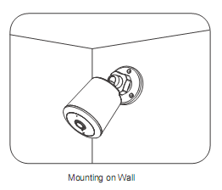
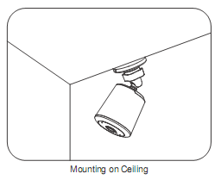

Camera usage Tips (interface may change with software update)
Tap on the pencil icon you can access the camera’s settings page
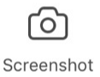
To take snapshot of the screen and save it to phone’s camera roll
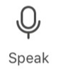
Tap to speak to the camera
Record live footage into your phone’s internal storage
Access to the footage recorded on the Micro SD card
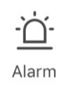
To turn the motion detection alarm on / off
To turn sound on/ off
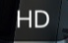To change video quality , high definition or standard definition
To access to camera’s settings page
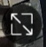To switch to full screen view mode
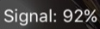: Wi-Fi signal, if signal is less than 60% you should consider changing the location or boost the WI-Fi Signal using Wi-Fi extender
 | 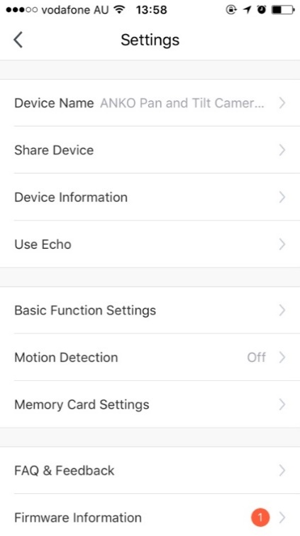 | Share Device: if you wish to share or remove sharing this camera with another genio APP user  Device information: details information for this camera, owner information, Virtual ID, IP address etc  Use Echo:  instruction on how to use with Amazon Alexa  Basic Function Settings:  Please ensure IR Night Vision is on Auto, and Talk Mode is on two way talk  Motion Detection:  On/Off and detection sensitivity level setting  Memory Card Settings:  This will only appear when 8GB-128GB Micro SD card is inserted  Firmware information: When new firmware is released for this camera you will see this notification icon.  Remove Device: Remove the device from current account so you can re-pair it again or pair under a different account/router
 | 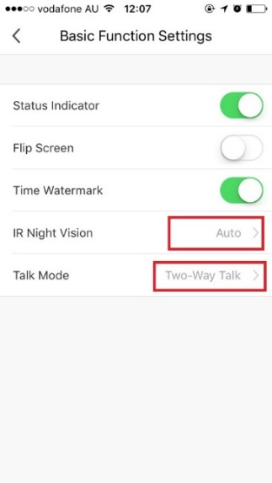
 | 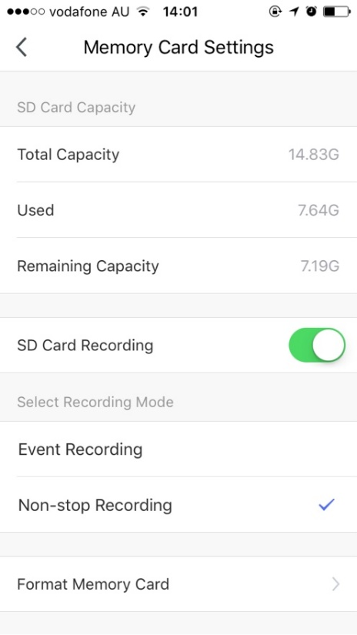 |  |  | SD Card Recoding: This option must be turned on if you want to record footage onto SD card and view it in playback mode  Event recording: Only records if it detects movement, motion detection option must be on at same time for it to work  Non-stop Recording: Camera will start to record 24/7, when SD card is full, new footage will automatically overwrite the old footage without end user action  Format Memory card: Delete all content on the SD card and formats the SD card into FAT32 format
 | We recommend use Scandisk, Verbatim, Kingston, Samsung - Class 10 high speed micro SD for best performance, When use non-stop recording a 32GB card can record up 6 days of footage. Event recording can record up to 4 weeks of footage.

Remember the performance of Wi-Fi camera is relies heavily on the performance of your router, before considering buying a new router or Wi-Fi extender.

If you are using Telstra NBN or a dual-band router, you must disable the 5GHz Wi-Fi in order to make a successful connection and for best overall performance, as MOST smart products in Australia only work on the 2.4Ghz signal.

FAQ:
How to connect camera to another router/genio account?
Go the camera’ settings page, look for “remove device” Remove it and reset the camera and pair it again through the APP.

Poor performance, takes a long time to load the live footage?
Please check the Wi-Fi signal, if it is less than 60%, you will need consider changing the camera location or purchase a Wi-Fi extender to boost the signal.

Camera goes offline and doesn’t reconnect back?
Go the camera’ settings page, look for “remove device” Remove it and reset the camera and pair it again through the APP.

Receive the Cannot find Device error?
Ensure the camera is in a location with strong Wi-Fi coverage
Manually disable the 5Ghz Wi-Fi signal on the router setting
Ensure that the 2.4Ghz Wi-Fi signal is on.
Ensure the indicator light is blinking RED rapidly as per APP screen (2 blinks per second)
Please check you have entered the correct 2.4Ghz Wi-Fi SSID and password
I am using Telstra NBN, I disabled the 5Ghz and I still cannot get it to pair?
Please follow paring instructions on https://mirabellagenio.net.au/faqs
If you have done all of the above, ensuring that the 5Ghz is disabled and the light changed from blinking red to blinking blue, but failed to become a solid blue, then your modem could not be incompatible with smart device.

All trademarks are used for reference purposes only. Made in China
ANKO, HOME&CO AND AUDIOSONIC® ARE TRADEMARKS OF KMART AUSTRLIA LIMITED.
MIRABELLA INTERNATIONAL PTY LTD
1 MIRABELLA DRIVE, TULLMARINE, VIC, AUSTRALIA 3043
TOLL FREE: 1800 636 528, www.mirabellagenio.com.au

