I003260 Smart Wi-Fi LED STRIPLIGHT INSTRUCTIONS
WARNING:
- LED STRIPLIGHT FOR INDOOR ONLY
- SAFETY EXTRA LOW VOLTAGE TRANSFORMER MUST REMAIN INDOORS AT ALL TIMES
TO ENSURE THE SAFE AND SATISFACTORY OPERATION OF THIS SET PLEASE READ THESE INSTRUCTIONS CAREFULLY AND RETAIN FOR FUTURE REFERENCE
FOR ANY QUESTIONS OR TROUBLESHOOTING PLEASE VISIT www.mirabellagenio.com.au/
We recommend that the set be tested prior to being set up in the desired location
SAFETY INFORMATION:-
• Remove set from packaging before connecting to the power supply.
• Before using or re-using the set, inspect the set carefully
• Use only with the transformer supplied
• Do not connect the set electrically to another set from a different manufacturer
• Ensure that the cable is completely uncoiled whilst set is in use.
Failure to do so may cause over-heating and subsequent malfunction
• Avoid damage to wire insulation (cable), as this could cause a short-circuit and damage the transformer
• Do not use any set which has been: cut, damaged, or has frayed wire insulation, loose connections or exposed wires
- The light strip is not suitable for dimmers, motion sensors or electric timer.

Note: When connecting, please ensure the arrows are aligned with one another
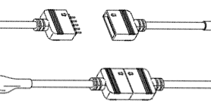
When cutting the strip light, please only cut along the cutline as outlined in the diagram
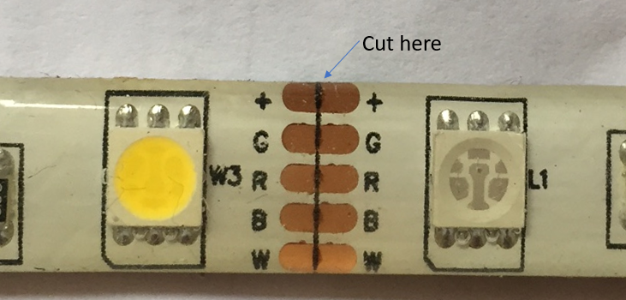
You can re-join the strip light with the 3pc connector which is included in the package
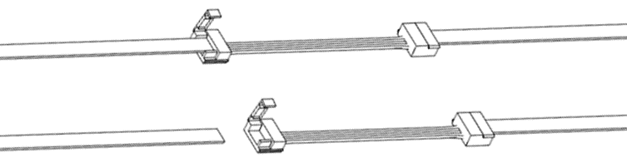

1. Connection Preparation
It is important that your phone is connected to 2.4Ghz Wi-Fi and not the 5GHz,
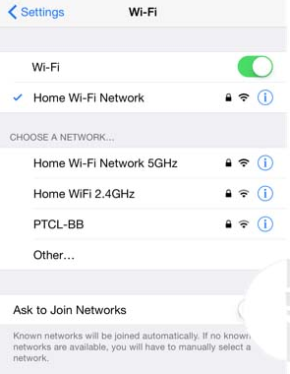
To verify your mobile phone is connected a 2.4Ghz Wi-Fi network, Navigate to the Setting menu and click on Wi-Fi. In this menu you will see all detectable networks in your area. Locate the SSID for your network, select a Wi-Fi SSID that doesn’t end with 5GHz.
Check you have a strong Wi-Fi signal (at least two bars) in the location where the smart device is installed. 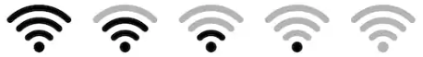
If you don’t have at least two bars signal on your phone, then you may need to reconsider the location or getting a Wi-Fi extender to boost the Wi-Fi signal strength.
If you have dual band router but you don’t see two Wi-Fi name SSID’s, one with 5G and one without 5G, you MUST log into the router and manually disable the 5Ghz Wi-Fi signal if you’re having connection issues.
Please contact your internet provider on how to disable 5Ghz Wi-Fi for your router.
- Install the APP and register Account
For the best experience, download the "Mirabella Genio" APP to your smartphone from the App Store or Google Play, the APP icon will be displayed after it’s installed successfully
- Pairing using Mirabella Genio App
Video Tutorials are available on https://mirabellagenio.net.au/led-strip-light
- Connect the strip light then Switch on power at wall, wait a few seconds, the strip light will commence blinking rapidly (2 blinks per second) , If it failed to start to blink rapidly when first powered on, press and hold the round paring button on the controller, until the light starts to blink rapidly
- Check and verify your mobile phone is connected to 2.4Ghz Wi-Fi network (5Ghz is not supported and must be disabled via the router setting during pairing)
- Open Mirabella Genio APP, tap on +, then choose from the list, and follow the APP to finish the pairing process
During the connection 0-100% countdown, strip light will stop blinking., HOWEVER at the end of the countdown, if the APP displays a, time out or device not found error, this mean the APP failed to communicate with your cloud services. Check and ensure
- light is blinking rapidly (2 blinks per second) not slowly (1 blink per 2 seconds) before pairing on the APP
- manually disable the 5Ghz Wi-Fi signal on the router setting (it can be turned back on after it has paired)
- re-start your router and try it again
If you have done all of the above, ensuring that the 5Ghz is disabled and the light has not stopped blinking, but still failed to connect to the Genio APP, then your modem could be incompatible with smart device or it may reach the maximum number of Wi-Fi devices it can handle.
For Telstra NBN or other dual-band routers, you MUST disable the 5Ghz Wi-Fi In order to make successful connection and for best overall performance. For Telstra NBN end user, you can also try follow the Guest Network paring instructions on https://mirabellagenio.net.au/faqs

Should the transformer, supply plug or supply flexible cord get damaged, do not attempt to repair.
TO BE REPAIRED BY AN AUTHORIZED PERSON ONLY
THIS IS AN AUSTRALIAN STANDARDS REQUIREMENT IN THE INTEREST OF YOUR SAFETY·

If the device appears to have gone offline and doesn’t reconnect back online by itself?
Go the device’ settings page (pencil or ... icon), look for “remove device” Remove it and reset the device and pair it again through the app.
MIRABELLA INTERNATIONAL PTY LTD
1 MIRABELLA DRIVE, TULLMARINE, VIC, AUSTRALIA 3043
TOLL FREE: 1800 636 528, www.mirabellagenio.com.au

