USB powered 2M LED Strip Light with Music Mode
WARNING:
- LED STRIPLIGHT FOR INDOOR ONLY, please use 5V 1A USB adaptor to power the light (not provided)
TO ENSURE THE SAFE AND SATISFACTORY OPERATION OF THIS SET PLEASE READ THESE INSTRUCTIONS CAREFULLY AND RETAIN FOR FUTURE REFERENCE
SAFETY INFORMATION:-
• Remove set from packaging before connecting to the USB adaptor
• Before using or re-using the set, inspect the set carefully
• Do not connect the set electrically to another set from a different manufacturer
• Ensure that the cable is completely uncoiled whilst set is in use.
Failure to do so may cause over-heating and subsequent malfunction
• Avoid damage to wire insulation (cable), as this could cause a short-circuit and
• Do not use any set which has been: cut, damaged, or has frayed wire insulation, loose connections or exposed wires
If you need to cut the strip, please only cut along the cutline as outlined in the diagram below.
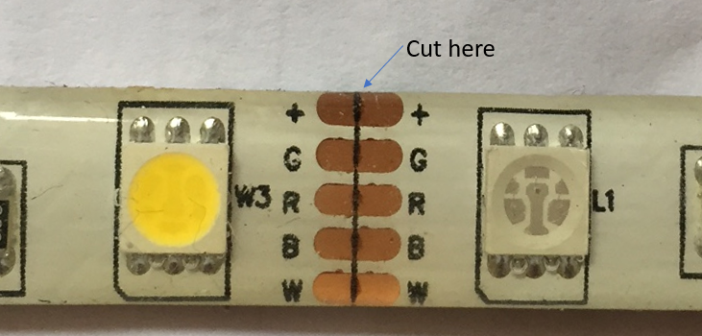
IR Remote:
Please ensure you point the IR remote within 6m of the strip light’s receiver module,
1.ON
2.OFF
3. Reduce brightness or speed to sync with music beat
4.Increase brightness or speed to sync with music beat
5. Colour panel
6. 3 colours jumping
7. 7 colours jumping
8. 3 colours fading
9. 7 colour fading
10. Timer mode: 1hour 2 hour, 3hour, 4 hour
11. Quick change mode
12. Slow change mode
13. Auto mode
14. White flash mode
15. Brightness, 25% 50% 75% 100%
16. Music mode

MIRABELLA INTERNATIONAL PTY LTD
1 MIRABELLA DRIVE, TULLMARINE, VIC, AUSTRALIA 3043
TOLL FREE: 1800 636 528, www.mirabellagenio.com.au

