Quick Start Guide
Genio Wi-Fi Mini Cube Indoor Camera
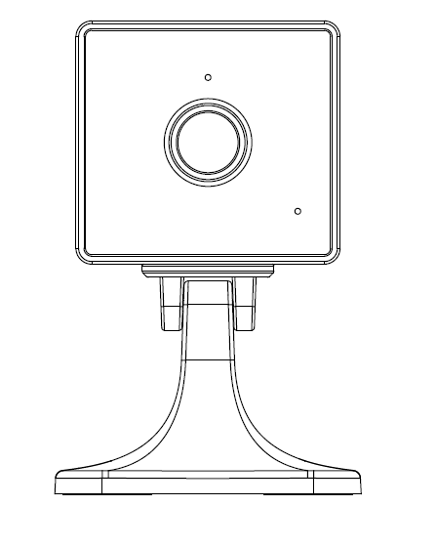
Model: I003202

Product Details
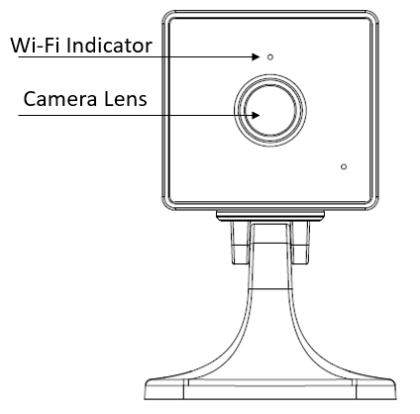
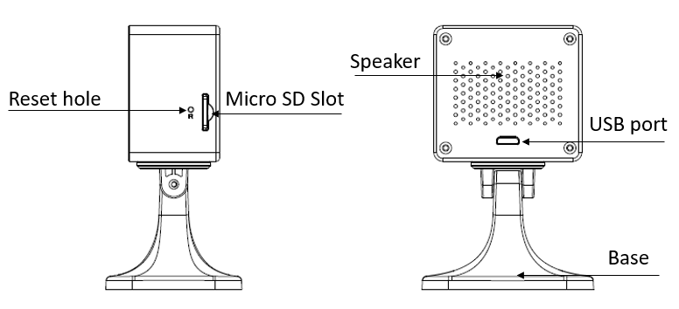
- Install the APP and register Account
For the best experience, download the "Mirabella Genio" APP to your smartphone from the App Store or Google Play, or you can also scan the QR code below, the APP icon will be displayed after installed successfully
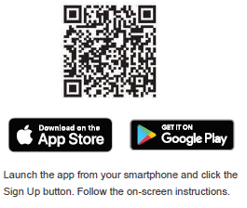
- Inserting the Micro SD card (Optional)
The Micro SD card slot is located on the side of the camera. Insert the Micro SD card gently into the slot as per below image.
Micro SD card size requirements: >8GB, Supports up to Max of 128Gb, FAT32 format only, doesn’t support NTFS file system.
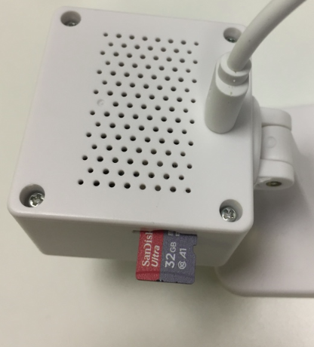

- Pairing the camera using Mirabella Genio App
- Connect the supplied USB charging cable to the camera’s USB port, then insert the other end of USB cable to a standard 5V 1A USB adaptor/charger (sold separately)
- Wait for 10-30 seconds, the Wi-Fi indicator light will then begin to blink RED rapidly, Camera is now ready to pair.
- Lunch Mirabella Genio APP, tap on +, then choose Security & Sensor , tap on the camera from the list of camera icons
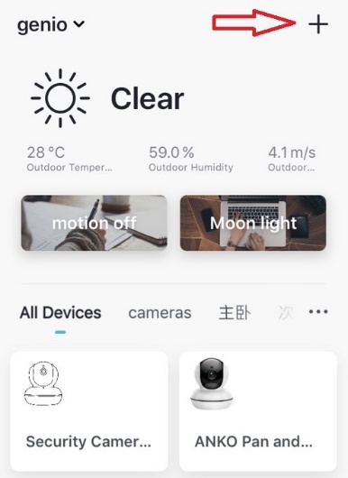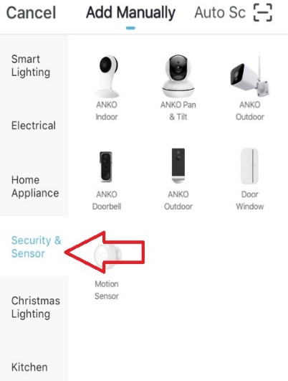
- Follow the in apps instruction carefully to complete the network pairing process. (this is the default QR code scanning method)
- face this QR code in front of the camera’s lens approximate 15-20cm, until you hear a “dongdongdong” sound, and Wi-Fi indicator light will change from blinking red to blinking yellow.
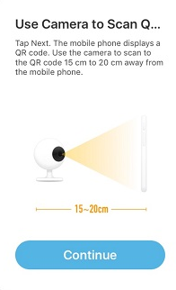 | 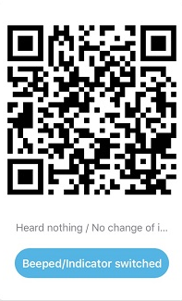
- Please wait for indicator light to became solid yellow, then tap the beeped/indicator switch button

- If your camera having difficulty scanning the QR code, please try using EZ mode method, which doesn’t require the scan of QR code ,
Tap on Net Pairing Mode, select EZ mode from the list
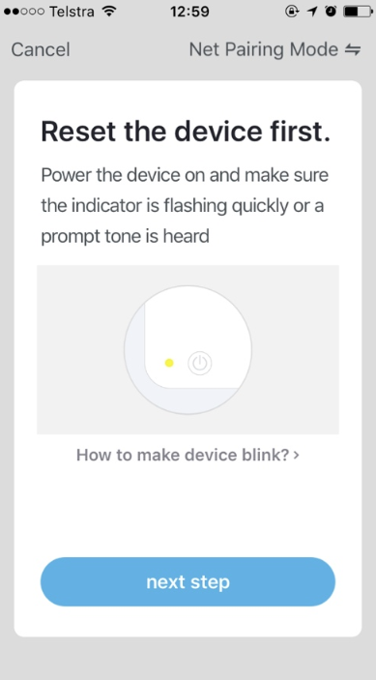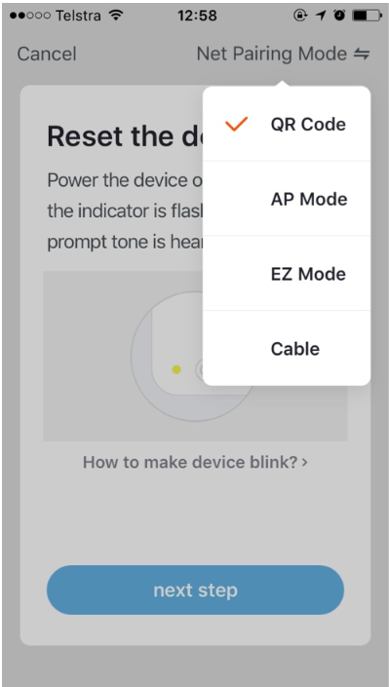
If After scanning the QR code or EZ mode method, the indicator light changed from blinking Red to blinking Yellow but failed to become solid Yellow and you received a ‘time out and device not found error’, this is an indication of communication error on the router. Please ensure the following;
- 5GHz Wi-Fi signal is disabled on the router setting for connection
- Wifi indicator light is blinking red rapidly
If the LED indicator light is not blinking red rapidly or it is blinking red slowly when first turned on, power off the camera, wait for 20 seconds, power on the camera, depress the reset hole using reset pin until you hear the “dongdongdong” sound, then release the pin, wait for another 30-40 seconds until the light is blinking red rapidly and repeat the pairing process again.
Camera’s Setting and usage Tips
Tap on the pencil icon you can access the camera’s settings page
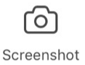to take snapshot of the screen and save it to phone’s camera roll
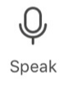press to enable two-way communication
record live footage into your phone’s internal storage
access to the footage recorded on the Micro SD card
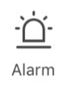to turn on or off the motion detection alarm
turn on/off the sound on
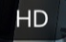change video quality, High definition or Standard definition
access to camera’s settings page
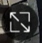switch to full screen view mode
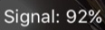: Wi-Fi signal, if signal is less than 60% you should consider changing the location of your router
 | 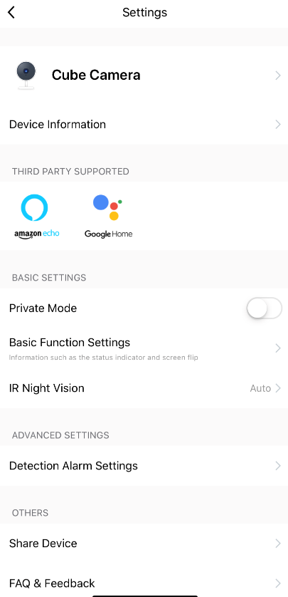 | Device information: detail information for this camera, owner information, Virtual ID, IP address etc  Private Mode: Privacy mode only your can view the camera  Basic Function Settings: please ensure Talk Mode is set as Two-Way Talk,  IR Night Version: please ensure it is on Auto  Detection Alarm Settings: on there you can set the motion detection On/off and change alarm sensitivity level setting and specify the Activity area  Memory Card Settings: this option will only appear when 8GB-128GB FAT32 format Micro SD card is inserted  Firmware information: when new firmware is release for this camera you will see a notification icon next to it.  Share Device, if you wish to share or remove sharing this camera with other genio account user  Remove Device: remove the device from current account so you can re-pair it again or pair under different account
 | 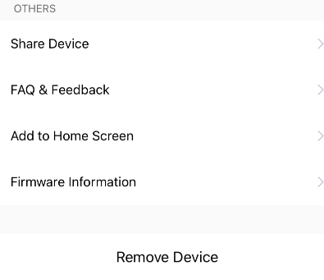 | 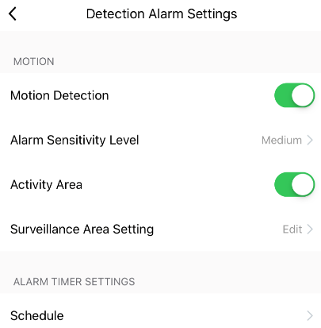
 | 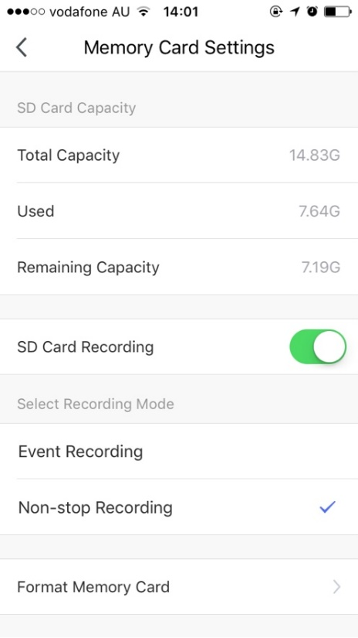 |  |  | SD Card Recoding: this option must turn on if you want to record footage into SD card and view it on playback  Event recording: only record if it detects motion movement, motion detection option must be on at same time for it to work  Non-stop Recording: camera will start to record 24/7, when SD is full new footage will automatically overwrite the old footage with out end user action  Format Memory card: delete all the contains on the SD card and format SD into FAT32 format
 | When use non-stop recording an 32GB card can record up 6 days of footage. Event recording can record up to 4 weeks of footages.
FAQ:
Which USB adaptor can I use?
Minimum requirements – 5V 1A adaptor
How to connect camera to another router?
Go the camera’ settings page, look for “remove device” Remove it and reset the camera and pair it again through the app.

Poor performance, take long time to load the live footage?
Please check the Wi-Fi signal, if it is less than 60%, you will need consider change the camera location or a better router is recommended to boost Wi-Fi coverage

Camera went offline and does not reconnect back online by itself?
Go the camera’ settings page, look for “remove device” Remove it and reset the camera and pair it again through the app.

Follow the pairing process but got error cannot find Device?
Please check following;
1. 5GHz Wi-Fi signal is disabled in the router settings for connection
2. indicator light is blinking red rapidly, not slowly
3. please check you enter the correct Wi-Fi SSID and password
4. phone is connected the 2.4GHz Wi-Fi and not 4G mobile data or 5GHz
If you have done all the correct setting above and it is still not connecting, please contact our technical team on Toll Free 1800 636 528 and an expert will be able to assist in getting you connected
Mirabella International
1 Mirabella Drive
Tullamarine VIC. 3043 Australia
P.O. Box 319, Tullamarine VIC. 3043 Australia
t: 1800 636 528
e: customerservice@mirabella.com.au

