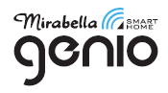I003028 7W LED Genio Wi-Fi Smart Tube Light
TO ENSURE THE SAFE AND SATISFACTORY OPERATION OF THIS SET PLEASE READ THESE INSTRUCTIONS CAREFULLY AND RETAIN FOR FUTURE REFERENCE
SAFETY INFORMATION:
• Remove set from packaging before connecting to power supply.
• Use only with adaptor supplied
•Ensure that the cable is completely uncoiled whilst set is in use.
•LED bulbs is non replaceable.
WI-FI pairing information
- Download “Mirabella Genio” App from the APP store or Google Play , and register an account
- Connect your mobile phone to 2.4Ghz Wi-Fi network (tube light doesn’t support 5Ghz Wi-Fi)
- Connect the adaptor to the tube light and switch the power on Tube light should start to blinking
- Open and login to mirabella genio APP, follow the in-app prompts to connect tube light to your Genio APP

If the tube light doesn’t start to blink when first powered on, then power off, then power on, Press and hold the on/off button on the top of tube light, until it starts to blinking, then pair it again 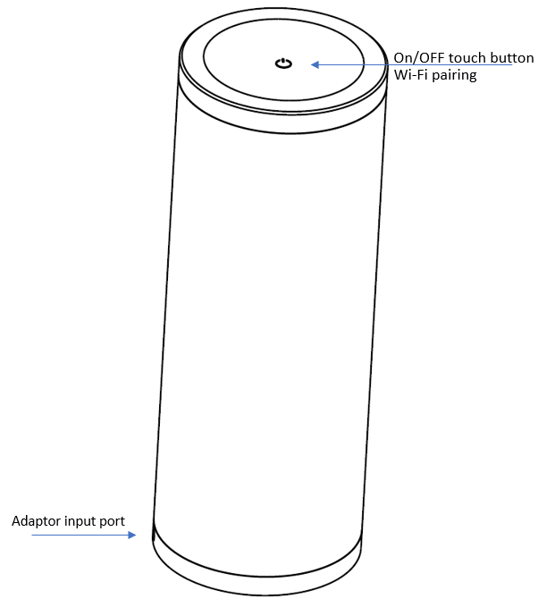
Should the tube light or adaptor get damaged, do not attempt to repair.
TO BE REPAIRED BY AN AUTHORIZED PERSON ONLY
THIS IS AN AUSTRALIAN STANDARDS REQUIREMENT IN THE INTEREST OF YOUR SAFETY
Mirabella International Pty Ltd
Toll Free: 1800 636 528
www.mirabellagenio.com.au

