Quick Start Guide
Genio Wi-Fi Pet feeder with HD camera
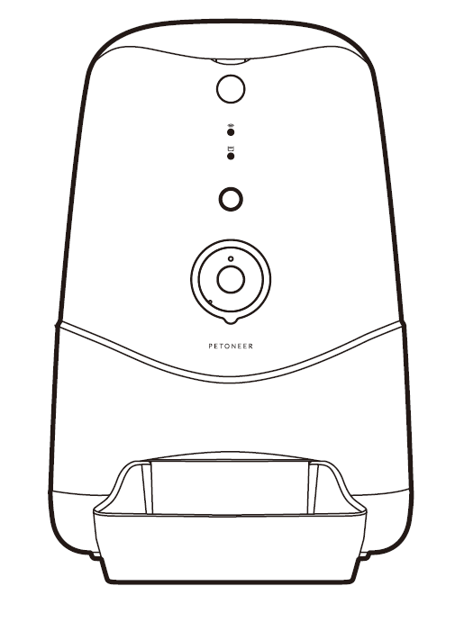

What’s included;
 | 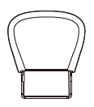 | 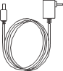
Pet Feeder | Feeding Tray | Power Adaptor
Product Details
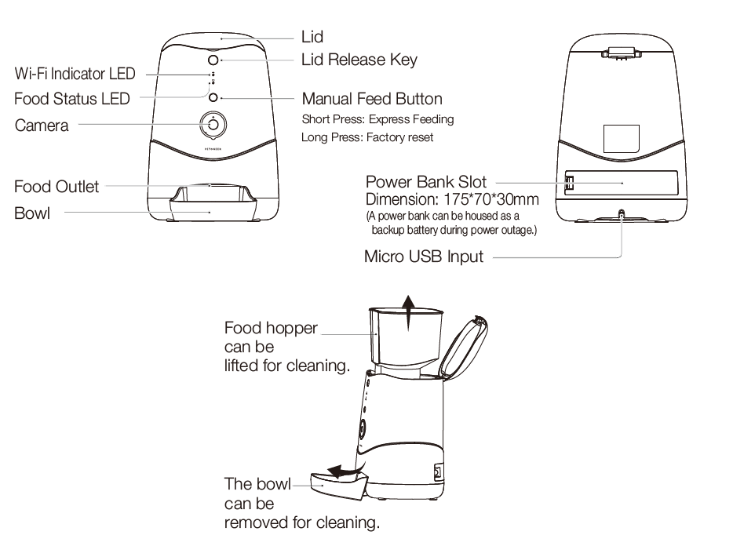

- Install the APP and register Account
For the best experience, download the "Mirabella Genio" app to your smartphone from App Store or Google Play alternatively, you can scan the QR code below, the Genio app icon will be displayed after installed successfully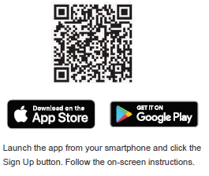
Safety & Warnings,
please read before using the pet feeder
- Only suitable for indoor use.
- Do not drop anything other than dry pet food into the food hopper. Failure to do so may cause malfunction.
- It is recommended the pet feeder be placed in a corner or up against a wall.
- Please shield or organise the power cord well to prevent your pet from biting the cable which can cause electric schock.
- Do not disassemble or modify the device yourself.
- This feeder is only suitable for dry food and is not suitable for wet food.
- This feeder is suitable for cats or small to medium-size dogs.
- The pet food’s shape and density will cause some deviations from the food hopper’s capacity and the feeding unit’s quantity.
- After each fill-up of the hopper, the portions may be different for the initial feeding. It is recommended to calibrate the feeder manually. (Click the manual feeding button until food is dispensed).

- Pet Feeder Installation
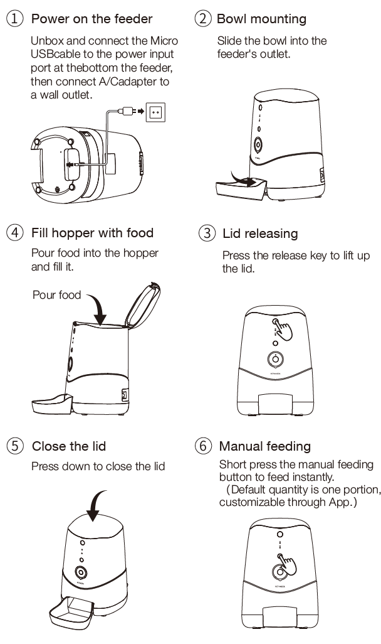

- Pairing the smart device using Mirabella Genio App
- Remove the pet feeder from the box, connect the adaptor to the pet feeder and plug adaptor into your wall socket.
- Wait for the Wi-Fi Status LED light start blinking slowly along with a start up sound. This can take a few minutes to load
If the Wi-Fi status LED did not blink when the pet feeder was turned on, press and hold the manual feeding button until it the Wi-Fi Status light begins to blink.
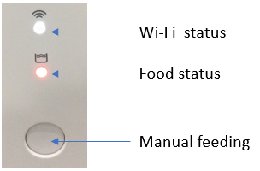
- Launch Mirabella Genio APP, tap on +, then choose Security & Sensor, select Genio Pet Feeder
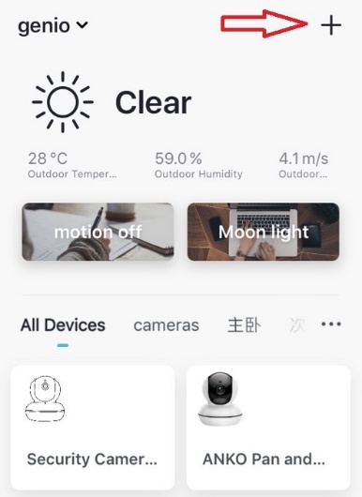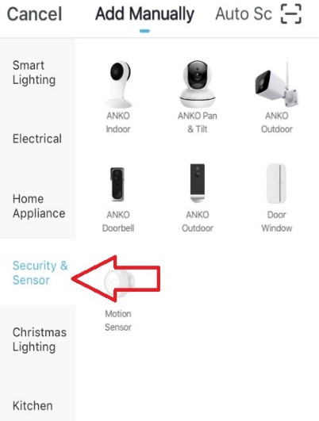
- Follow the in app prompts carefully to complete the network pairing process. (default QR code scanning method)
- If your pet feeder having difficulty scanning the QR code, an alternative process is by using AP mode method, by tapping on Net Pairing mode-> Select “AP Mode” , then hit “next step”
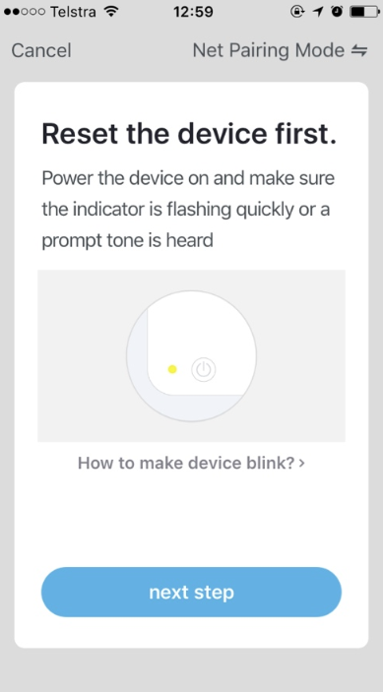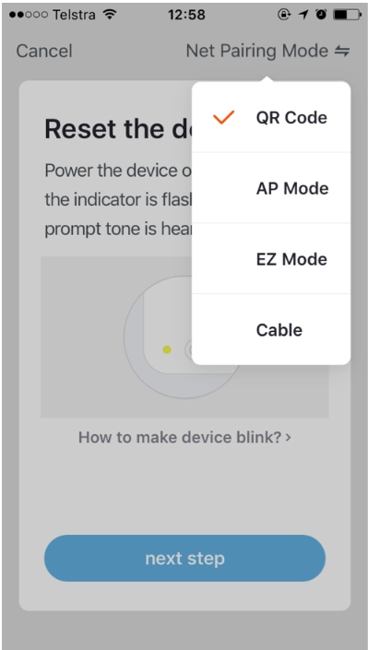
- Make sure the pet feeder LED is blinking red slowly, and connect the phone to to pet feeder’s network, SmartLife_xxxxxx
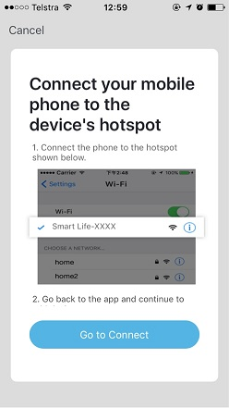 | 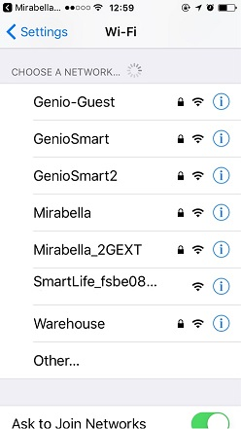 | 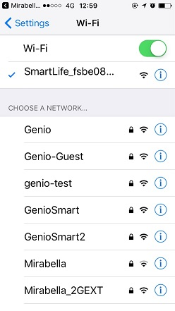
- Return to Genio app and follow the in app instruction to complete the network pairing process.

Pet Feeder usage Tips (The interface may change subject to software updates)

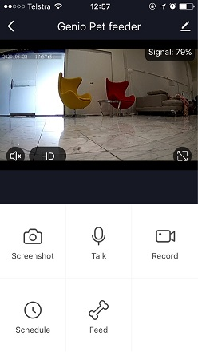 | to take snapshot and save it to phone’s camera roll  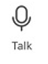 press and talk to your pet  record live footage into your phone’s internal storage  set a schedule to feed your pet  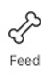tap feed button to release food from the food hopper
turn on/off the sound on
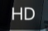 change video quality , high definition HD or Standard definition SD
access to pet feeder’s settings page
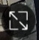 switch to full screen view mode
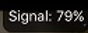: Wi-Fi signal, if signal is less than 60% you should consider change the location or boost it the WI-Fi Signal using WiFi extender
Tap on the pencil icon you can access the pet feeder’s Settings page;
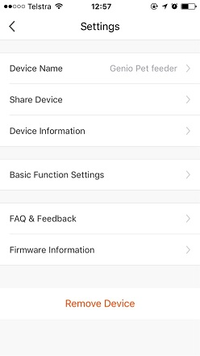  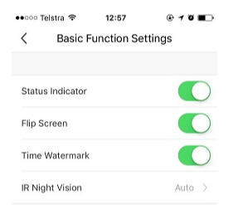 | Share Device: sharing this pet feeder with other Genio end user  Device information: detail information for this pet feeder, owner information, Virtual ID, IP address etc  Basic Function Settings: access to status indicator on/off, Flip screen, Time Watermark option  IR Night Vision: on/off or Auto  FAQ & Feedback: read FAQ or sending improvement suggestion or product issue via online feedback system  Firmware information: when new firmware is release for this pet feeder you will see a notification icon next to it.  Remove Device: remove the device from current account so you can re-pair it again or pair under different account

FAQ:
Food Status indicator light:
What does it mean when it is blinking red?
You have less than 20% food left in the hopper, ensure to refill
What does it mean when it is sold red?
The pet feeder is out of food, please refill immediately
How to connect pet feeder to another router?
Go the pet feeder’ settings page, look for “remove device” Remove it and reset the pet feeder and pair it again through the app.

Poor performance, taking long time to load the live footage?
Please check the Wi-Fi signal, if it is less than 65%, you will need to consider changing the pet feeders location or improving your modem/router

Pet feeder went offline and doesn’t reconnect back online by itself?
Go the pet feeder’ settings page, look for “remove device” Remove it and reset the pet feeder and pair it again through the app.

Followed the pairing process, went to 100% and received error ‘Cannot find Device’?
1.Disable the 5GHz network or create a Guest 2.4GHz account in your router settings. Contact your service provider for further details
2. Ensure Wi-Fi LED indicator light is blinking slowly
3. Ensure phone is on the 2.4GHz Wi-Fi network and not 4G mobile data or 5GHz

Need further assistance from Mirabella technical support?
In the genio app home screen, tap on, Me, -> FAQ & Feedback -> Report issue
Fill in the fault information or suggest for the app/product, then submit
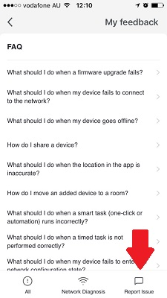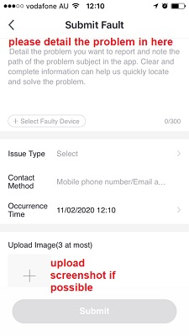

Mirabella International
1 Mirabella Drive
Tullamarine VIC. 3043 Australia
P.O. Box 319, Tullamarine VIC. 3043 Australia
t: 1800 636 528
e: customerservice@mirabella.com.au

