Outdoor Solar Panel
Compatible with ANKO Rechargeable Camera 42799351 & Doorbell 42768514
Step 1. Please place in a position with maximised sun light exposure throughout the year for your solar panel.
Step 2. Mount the bracket and secure with the screws provided
Step 3. Install the solar panel into the bracket and ensure its secure.
Step 4. Loosen the adjusting screw on the bracket and adjust the angle of the solar panel to ensure it receives direct sunlight exposure and then tighten the adjusting screw.
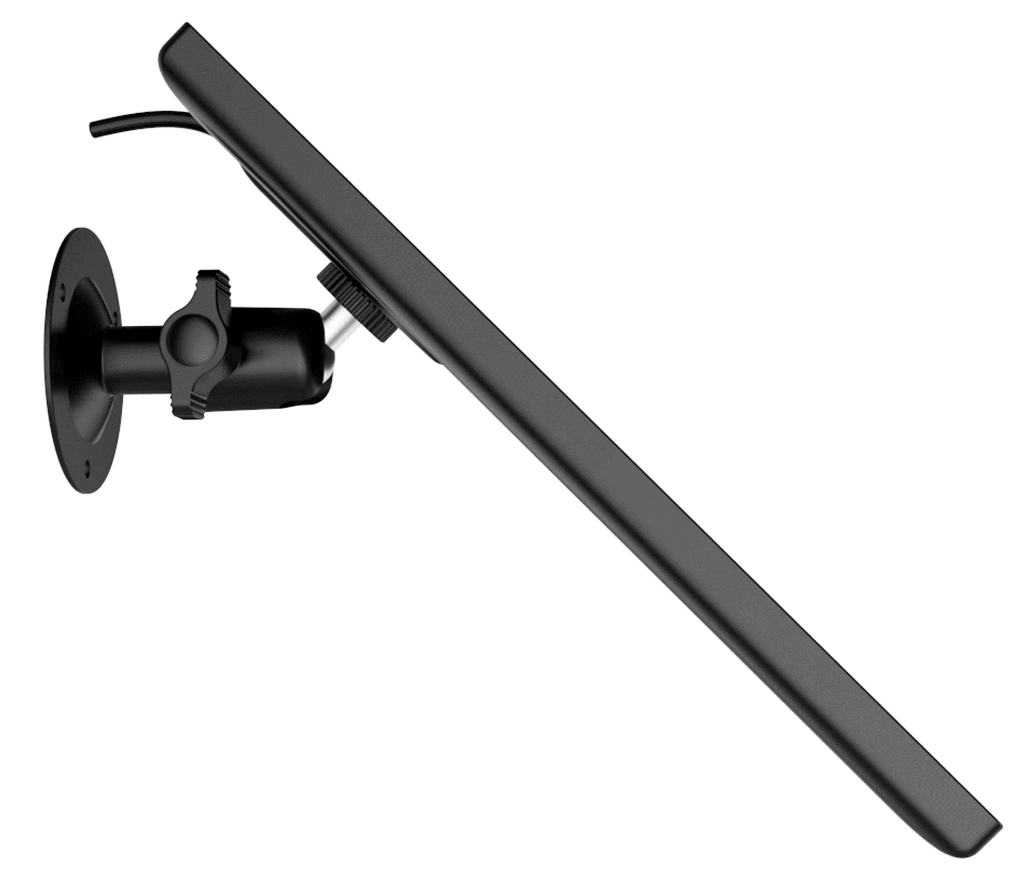
Step 5. Connect the solar panel to your Wi-Fi camera by inserting the micro USB cable into the base.
Notes:
Please do not install the solar panel completely horizontally. Otherwise, your solar panel might accumulate dust and other debris easily. It is advised to install the solar panel angularly to make it receive direct sunlight exposure.
Wipe the solar panel regularly to remove the dust and debris.
Solar panel may not be able to keep your camera fully charged on days that are snowy, cloudy, gloomy, or rainy or during periods of extensive use (frequent access or constant triggers). External factors, such as shade, temperature, weather, and amount of dust or debris on its surface, may also affect the effective of Solar Panel in generating electricity.
Avoid locations like the shadow of trees, buildings, or other obstacles to ensure sufficient sunlight.
Adjust the direction of your solar panel to face the true south (in the northern hemisphere) or the true north (in the southern hemisphere) and tilt it to the appropriate angle according to your latitude to ensure maximum sun exposure.
For the safety of your camera’s battery please charge the batteries in temperature between -20°C and 50°C only.
Solar Panel Specification:
Pmax: 3W , Vmp: 5.0V, Imp: 0.573A, USB cable: 3M

