Genio Smart Wi-Fi Neon LED Light Instruction
WARNING:
- LED STRIPLIGHT FOR INDOOR OR OUTDOOR USE
- SAFETY EXTRA LOW VOLTAGE TRANSFORMER MUST REMAIN INDOORS ONLY – IT CANNOT BE EXPOSED TO THE WEATHER
TO ENSURE THE SAFE AND SATISFACTORY OPERATION OF THIS SET PLEASE READ THESE INSTRUCTIONS CAREFULLY AND RETAIN FOR FUTURE REFERENCE
FOR ANY QUESTIONS OR TROUBLESHOOTING PLEASE VISIT www.mirabellagenio.com.au
We recommend that the set be tested prior to being set up in the desired location
SAFETY INFORMATION:
• Remove set from packaging before connecting to power supply.
• Before using or re-using the set, inspect carefully
• Use only with transformer supplied
• Do not connect set electrically to another set
• Ensure that all the cable is completely uncoiled whilst set is in use. Failure to do so may cause over-heating and subsequent malfunction
• Avoid damage to wire insulation (cable), as this could cause a short-circuit and damage the transformer
• Do not use any set which has: – cut, damaged, or frayed wire insulation, cracks in lamp-holders, loose connections or exposed wires
Note: When connecting the controller to the light, please ensure the arrows are aligned with one another
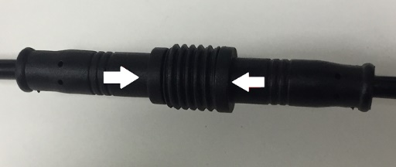
Install the APP and register Account
For the best experience, download the "Mirabella Genio" APP to your smartphone from App Store or Google Play, and register an account using your email address

Pairing using Mirabella Genio App
Connect the neon light strip to the Wi-Fi controller and connect controller to the adaptor, then switch on power at wall, wait a few seconds, neon light will start to blink rapidly
If it did not automatically start to blink rapidly when first powered on, power off, wait for 5sec, then on-off-on-off-on the power switch, wait for the neon light start to blink
- Check and verify your mobile phone is connected to 2.4Ghz Wi-Fi network (5Ghz is not supported)
- Lunch Mirabella Genio APP, tap on +, then choose smart lighting from the list, follow the instruction on the APP to pair the neon light,
- if the APP display time out device not found error, this mean the APP failed communicate with our cloud services. Please check/try
- light is blinking rapidly, not slowly, if unsure, please reset it by turn it on/off 3 times
- ensure disable the 5Ghz Wi-Fi signal on the router setting
- please connect using Guest 2.4Ghz Wi-Fi
- Contact Mirabella Technical Support Hot Line

if the fast-blinking method (EZ method, mentioned above) doesn’t work, please try the slow blinking (AP method) below.
While the light is rapidly blinking, off on off on off on, then wait for the light start to blinking slowly (1 blink per every 2 second)
1. open up the Mirabella genio APP, tap on + , select genio neon light
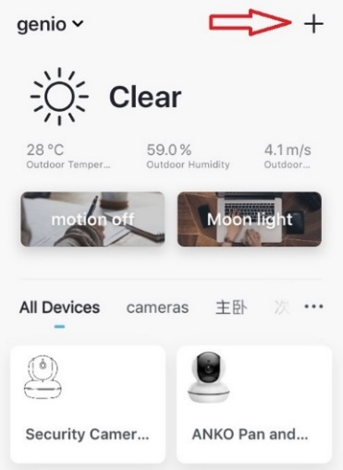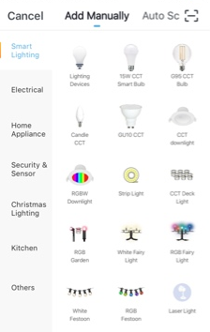
Entre your Wi-Fi name and password, then in reset the device first screen tap on EZ mode in the Top right hand corner just below the battery image , select AP Mode (refer to the 1st and 2nd image below)
- Now Confirm indicator slowly blinking (refer to image 3), hit Next, then Go to connect and connect to Wi-Fi named SmartLife_XXXX
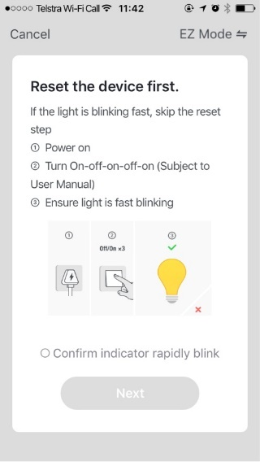 | 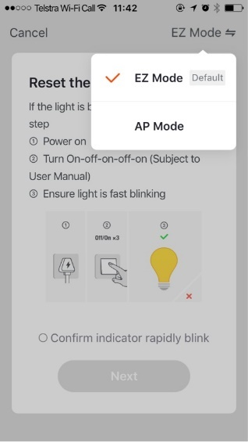 | 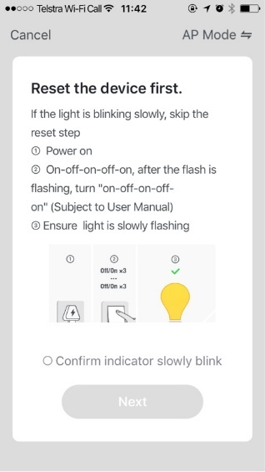
Note: If you fail to see Wi-Fi name beginning with the word SmartLife_XXXX, then mean the device is not slowly blinking,
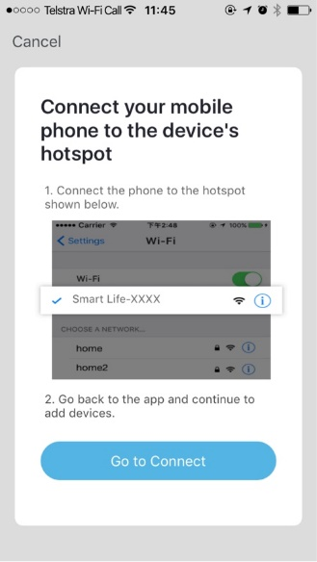 | 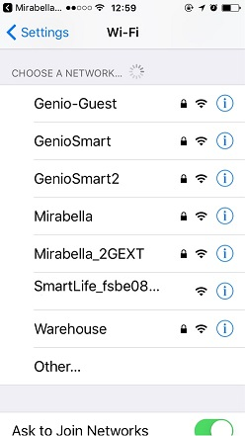 | 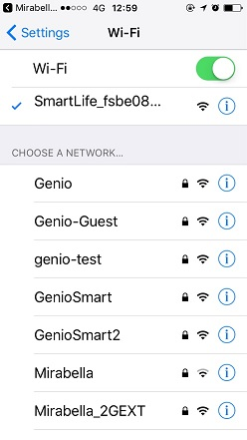
After connected to SmartLife_XXXX, return to Mirabella Genio, APP will commence the 0-100% countdown process
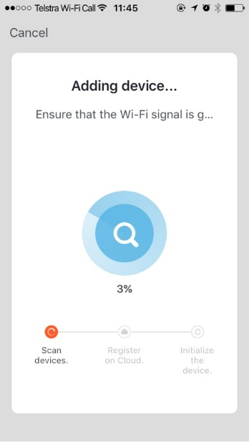 | Please pay attention to the screen to determent the cause of time-out error  If the light never stops blinking, there could be issue with the product itself, please return it  if light does stop blinking, but unable progress to “register on cloud” it indicates communication error with your router to our cloud service (need to check router setting) | please check and ensure  1. You enter the correct 2.4Ghz Wi-Fi name and password  2.Your light is receiving good Wi-Fi signal, and it is not covered by glass or metal shade  3. 5Ghz Wi-Fi signal is turned off on the router

Should the transformer, supply plug or supply flexible cord get damaged, do not attempt to repair.
TO BE REPAIRED BY AN AUTHORIZED PERSON ONLY
THIS IS AN AUSTRALIAN STANDARDS REQUIREMENT IN THE INTEREST OF YOUR SAFETY·
Mirabella International Pty Ltd
Made In China

