I002923 Genio Smart Wi-Fi LED Stick Light
WARNING:
- SAFETY EXTRA LOW VOLTAGE TRANSFORMER MUST REMAIN INDOORS ONLY – IT CANNOT BE EXPOSED TO THE WEATHER
TO ENSURE THE SAFE AND SATISFACTORY OPERATION OF THIS SET PLEASE READ THESE INSTRUCTIONS CAREFULLY AND RETAIN FOR FUTURE REFERENCE
FOR ANY QUESTIONS OR TROUBLESHOOTING PLEASE VISIT www.mirabellagenio.net.au/faqs
We recommend that the set be tested prior to being set up in the desired location
SAFETY INFORMATION:
• Remove set from packaging before connecting to power supply.
• Before using or re-using the set, inspect carefully
• Use only with transformer supplied
• Do not connect set electrically to another set
• Do not use any set which has: – cut, damaged, or frayed wire insulation, cracks in lamp-holders,
loose connections or exposed wires
- The LED bulb is not replaceable
Wi-fi controller
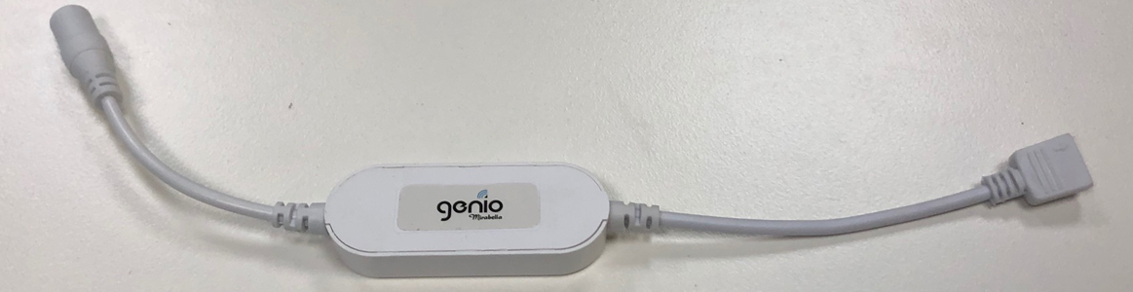
Note: When connecting, please ensure the arrows are aligned with one another
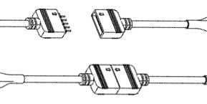
Included in the Kit
x8 | 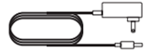 | 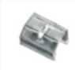x 8 | 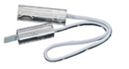x4 | 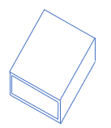 x1
Installation Screws | Power Adaptor | Installation clips | Extension cables | Rubber end cap

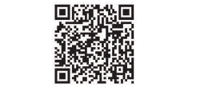
- Install the APP and register Account
For the best experience, download the "Mirabella Genio" APP to your smartphone from App Store or Google Play, or you can also scan the QR code below, the APP icon will be displayed after it’s installed successfully

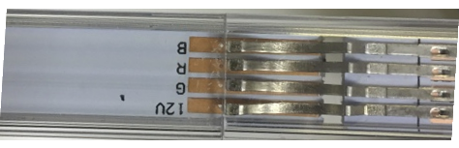
- Link and connect the stick light
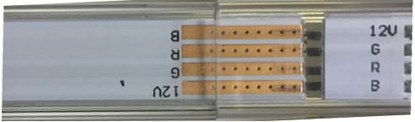
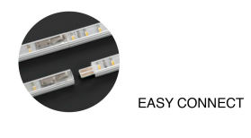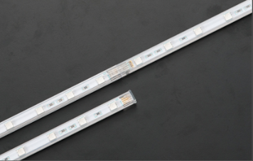
It is recommed you connect the stick light according to the ABCD marking. A-A, B-B, C-C D-D etc, and cover the end with rubber end cap.

- Pairing using Mirabella Genio App
- Connect the stick light then Switch on power at wall, wait a few seconds, stick light will start to blink rapidly (2 blinks per second)
- If it failed to blink rapidly when first powered on, press and hold the paring button on the Wi-Fi controller, until the light starts to blink rapidly
- Check and verify your mobile phone is connected to 2.4Ghz Wi-Fi network (5Ghz Wi-Fi is not supported and may need to disabled on the router setting in order to make successful pairing and overall performances)
- Open Mirabella Genio APP, tap on +, go to Smart Light -> Genio Smart Lighting
- Follow the App instruction to finish the pairing process
During the connection 0-100% countdown, light will stop blinking., HOWEVER after end of 100% countdown, if the APP display device not found error, this mean the APP failed communicate with our cloud services.
- Please ensure the 5Ghz Wi-Fi signal is disabled on the router setting, please contact your internet provider
- Please ensure your phone is connected to 2.4Ghz Wi-Fi signal, Wi-Fi name should not end with -5G
- Please ensure you enter the correct Wi-Fi name and password
- Please check light is blinking rapidly (2 blinks per second) before starting the paring process
Should the transformer, supply plug or supply flexible cord get damaged, do not attempt to repair.
TO BE REPAIRED BY AN AUTHORIZED PERSON ONLY
THIS IS AN AUSTRALIAN STANDARDS REQUIREMENT IN THE INTEREST OF YOUR SAFETY·

I am using Telstra NBN, I disabled the 5Ghz and I still cannot get it to pair?
Please follow the Guest Network paring instructions on https://mirabellagenio.net.au/faqs
If you have done all of the above, ensuring that the 5Ghz is disabled and the light can stop blinking but doesn’t pair in the APP then your modem could be incompatible with our smart device.

Specifications
- 12 LEDs per stick
- Length of stick = 40cm
- Adaptor Output: 12V DC 0.5A
- IP20
MIRABELLA INTERNATIONAL PTY LTD
1 MIRABELLA DRIVE, TULLMARINE, VIC, AUSTRALIA 3043
TOLL FREE: 1800 636 528, www.mirabellagenio.com.au
V4 30/10/2020

