I002922 Genio Smart Wi-Fi LED Cabinet Light
WARNING:
- SAFETY EXTRA LOW VOLTAGE TRANSFORMER MUST REMAIN INDOORS ONLY – IT CANNOT BE EXPOSED TO THE WEATHER
TO ENSURE THE SAFE AND SATISFACTORY OPERATION OF THIS SET PLEASE READ THESE INSTRUCTIONS CAREFULLY AND RETAIN FOR FUTURE REFERENCE
FOR ANY QUESTIONS OR TROUBLESHOOTING PLEASE VISIT www.mirabellagenio.com.au
We recommend that the set be tested & pair it prior to being set up in the desired location
SAFETY INFORMATION:
• Remove set from packaging before connecting to power supply.
• Before using or re-using the set, inspect carefully
• Use only with transformer supplied
• Do not connect set electrically to another set
• Do not use any set which has: – cut, damaged, or frayed wire insulation, cracks in lamp-holders,
loose connections or exposed wires
- The LED bulb is not replaceable

Included in the Kit
Wi-fi controller
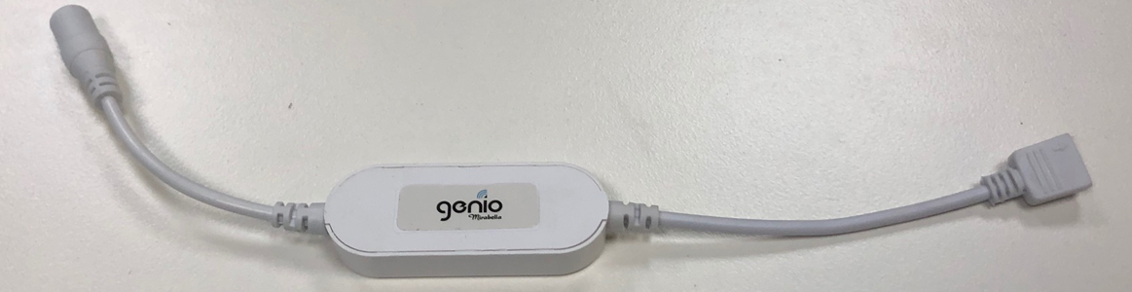
Note: When connecting, please ensure the arrows are aligned with one another
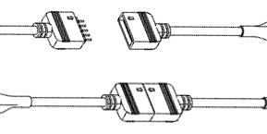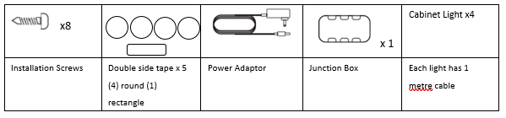

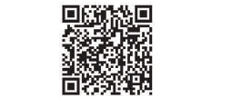
Install the APP and register Account
For the best experience, download the "Mirabella Genio" APP to your smartphone from App Store or Google Play, or you can also scan the QR code below, the APP icon will be displayed after it’s installed successfully
Before you begin installation, you need to determine the light placement.
Ensure that the placement will allow for the adaptor to be able to be plugged into a power point outlet.
If drilling thru cabinets, we recommend using a 12mm hole saw
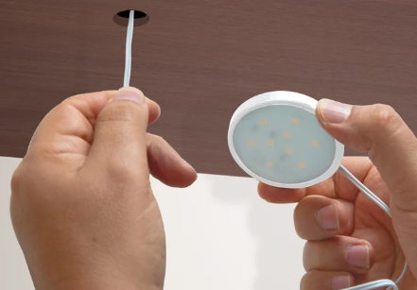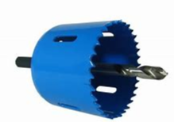
Installation of the Cabinet Lights (if using screws).
- Connect the cabinet lights power cables to the junction box.
- Locate a central position for the junction box.
- Use the rectangle double sided tape to fix the junction box into place.
- Unscrew the cabinet light by turning the top section counter clockwise, then separate the top cover including the white lens from the bottom assembly. (refer to diagram 1 below)
5. Place the cabinet lights in the desired position, using a marker, mark the position of the installation
screw holes and drill the holes accordingly. (refer to diagram 2 below)
6. Fasten the cabinet light assembly using the screws provided. (refer to diagram 3 below)
4. Reinstall the cabinet light by screwing the top section clockwise onto the cabinet light assembly. (refer to -diagram 4 below)
5. Repeat steps 1 to 4 for each cabinet you want to install.
7. Connect Wi-Fi controller to the junction box
8. Connect the power adaptor to the Wi-Fi controller
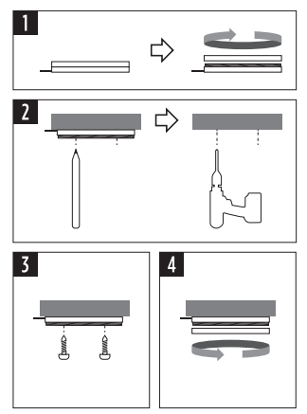

Installation of the Cabinet Lights (if using double sided tape).
- Connect the cabinet lights power cables to the junction box.
- Locate a central position for the junction box.
- Use the rectangle double sided tape to fix the junction box into place.
- Place the cabinet lights in the desired position, using the round double-sided tape.
- Connect Wi-Fi controller to the junction box
- Connect the power adaptor to the Wi-Fi controller

Pairing using Mirabella Genio App
- Switch on power at wall, wait a few seconds, cabinet light will start to blink rapidly
- If it did not automatically start to blink fast when first powered on, press and hold the paring button on the controller, until the light starts to blink fast (2 blinks per sec)
- Ensure your mobile phone is connected to 2.4Ghz Wi-Fi network
- Please note that (5GHz Wi-Fi is not supported and must be disabled on the router setting during pairing)
- Once the unit has been paired, 5GHz can then be enabled.
- Launch Mirabella Genio app, tap on plus symbol “+” (located top right hand corner),
- Go to Smart Lighting -> Genio lighting devices
- Follow the App instruction to finish the pairing process

During the 0-100% buffering, the light will stop blinking during this process.
HOWEVER if the connection buffers to 100% and times out, In this instance, it means that the unit has not successfully paired. To trouble shoot this please refer to the 4 points detailed below.
- Check light is blinking rapidly, (2 blinks per second)
- Ensure the 5Ghz Wi-Fi signal is disabled on your router
- Ensure your phone is connected to 2.4Ghz Wi-Fi signal, not the 4G/5G network
- Ensure you enter the correct Wi-Fi name and password
Should the transformer, supply plug or supply flexible cord get damaged, do not attempt to repair.
TO BE REPAIRED BY AN AUTHORIZED PERSON ONLY
THIS IS AN AUSTRALIAN STANDARDS REQUIREMENT IN THE INTEREST OF YOUR SAFETY·
I am using Telstra NBN, I disabled the 5Ghz and I still cannot get it to pair?
Please follow the Guest Network paring instructions on https://mirabellagenio.net.au/faqs
Specifications
- 9 LEDs per cabinet light
- Size of the cabinet light = 60 x 8mm
- Adaptor output: 12V DC 0.5A
- IP20
Mirabella International Pty Ltd
1 Mirabella Drive Tullamarine VIC 3043 Australia
1800 636 528
Made in China

