Quick Start Guide
FULL HD Wi-Fi Pan & Tilt Baby Camera
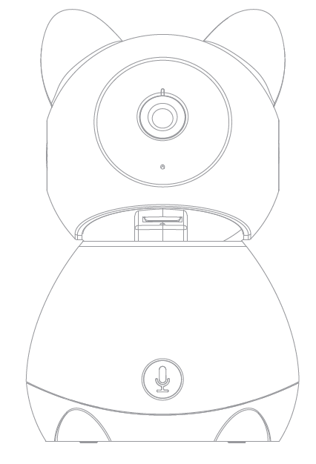
Model: I002867
V2.0.0 19.8.2020

What’s included
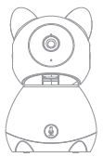 | 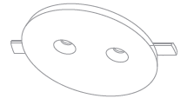 | 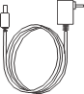
Baby Camera | Bracket | Power Adaptor | screw sets
Product Details
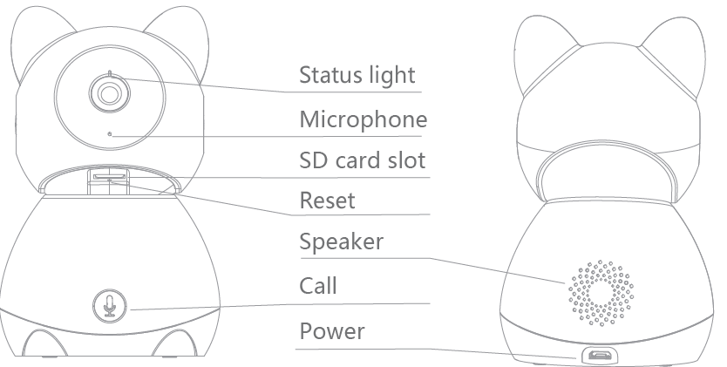

Connection Preparation
It is important that your phone is connect to 2.4Ghz Wi-Fi and not to the 5GHz network.
To verify your mobile device is set to a 2.4Ghz Wi-Fi network, navigate to the Settings menu and click on Wi-Fi. In this menu you will see all the detectable networks in your area. Locate the SSID (the name of your network), and ensure that the Wi-Fi SSID does not end with a 5G / 5GHz.
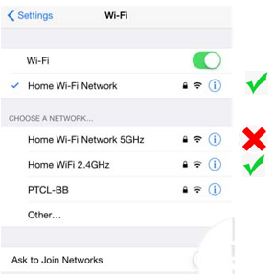
Check you have a strong WI-FI signal (at least two bars) in the location where the smart camera is to be installed. 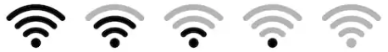
If you don’t have at least two bars signal on your phone, then you may need to reconsider the relocating the camera to a different location or obtain a Wi-Fi extender to boost the WI-FI signal strength.

- Install the APP and register Account
Download the "Mirabella Genio" APP to your smartphone from the App Store or Google Play, or you can also scan the QR code below, the APP icon will be displayed after installed successfully
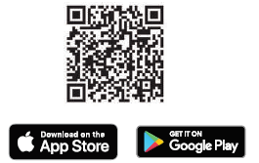
2. Insert the Micro SD card (not included) The camera is able to work without a Micro SD card but it will not able to record any footage without a Micro SD card.
Rotate the camera by hand, let the camera lens towards ceiling to expose the Micro SD card slot. Insert the Micro SD card gently into the slot, please pay attention with the direction of the Micro SD card, do not force it in.
Micro SD card size needs to be greater than 8GB, Supports up to Max of 128GB.

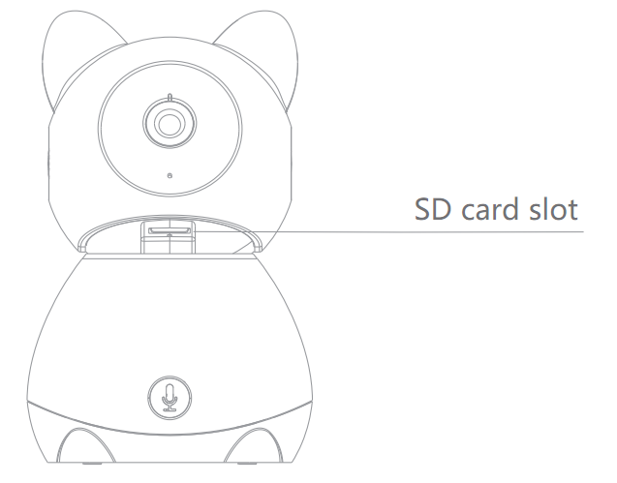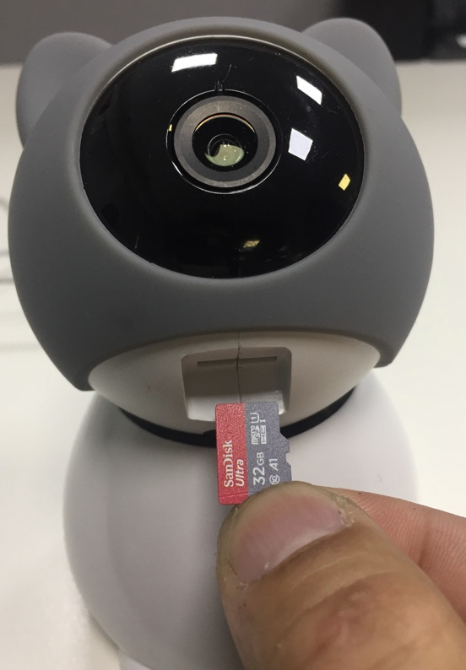

- Camera Installation
Use the included mounting bracket to fix the camera to a clean surface
Or put the camera on a flat surface
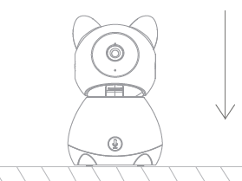

- Pairing the camera using Mirabella Genio App
- Connect the supplied adaptor to the camera and turn on the power switch .
- Wait for 10-40 seconds, the indicator light will start to blinking rapidly in RED (2 blinks per second) camera is now ready to pair

- Please ensure your mobile phone is connected to your 2.4Ghz Wi-Fi network (the camera is not compatible with 5GHz Wi-Fi network)

- Launch Mirabella Genio APP, tap on +, then choose Security & Sensor , select your camera from the menu.
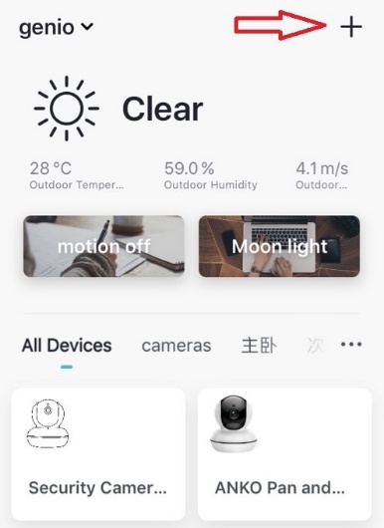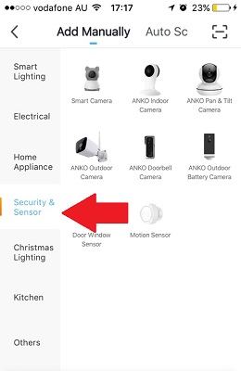
- Ensure the LED indicator light is still blinking red fast, tap next step and enter your 2.4GHz Wi-Fi name and password
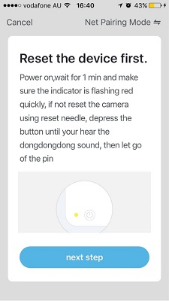 | 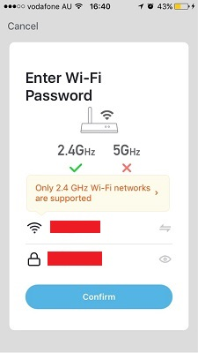

- Tap continue and QR code will appear, face this QR code in front of the camera approximate 15-20cm, until your hear a “dongdongdong” sound,
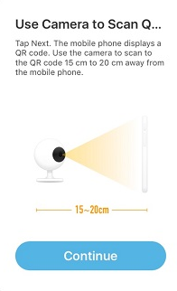 | 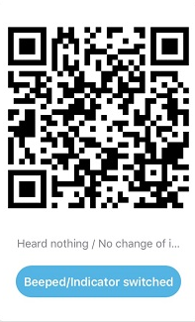
- Please wait for indicator light changed to solid BLUE, then tap the beeped/indicator switch button
- Camera is now successfully added into your APP.
Please refer to the FAQ section for troubleshooting if this method does not connect.
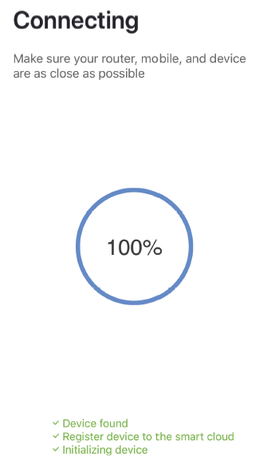 | 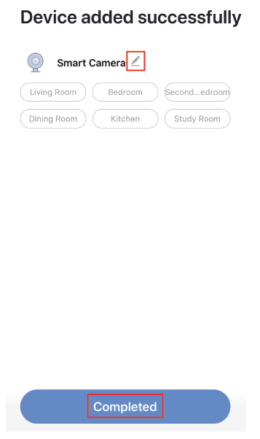
Camera interface is subject to slight alterations based on firmware updates
Tap on the pencil icon or … icon you can access the camera’s Settings page
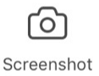 to take snapshot of the screen and save it to phone’s camera roll
tap to speak to the camera
record live footage into your phone’s internal storage
access to the footage recorded on the Micro SD card
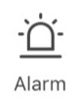 to turn on or off the motion detection alarm
play the built in lullaby melodies

To turn on/off the sound on
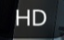 To change video quality , high definition HD or Standard definition SD
To access to camera’s settings
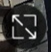 To switch to full screen view mode
: Wi-Fi signal, if signal is less than 60% you should consider changing the location or boost the WI-Fi Signal using Wi-Fi extender
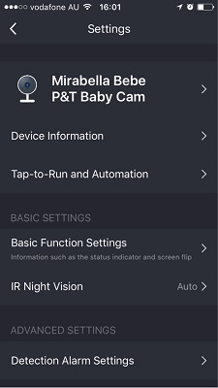 | Device information:  Detailed information for this camera, owner information, Virtual ID, IP address etc  Basic Function Settings:  Access to status indicator on/off, Flip screen, Time Watermark option  IR Night Vision: On/off or Auto  Detection Alarm Settings: Access to motion sound & cry detection options  Memory Card Settings: This will only appear when 8GB-128GB Micro SD card is inserted  Share Device: Share this camera with other Genio accounts  FAQ & Feedback: Read FAQ or send improvement suggestions or product issues via online feedback system  Add to Home Screen: Add a quick access link to your phones home screen  Firmware information: When new firmware is released for this camera you will see a notification icon next to it.  Remove Device: Remove the device from current account so you can re-pair it again or pair under a different account or different Wi-Fi network
Status indicator: This will turn off the blue status indicator light on your camera, please keep it on

Talk Mode: You can either select one way or two way talk mode, please use two way talk

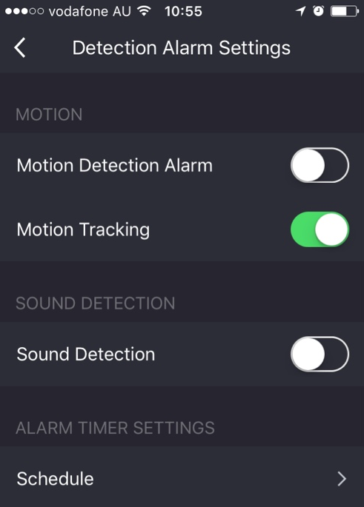 | Detection Alarm Settings  Motion Detection: turn on/off motion detection or adjust the sensitivity level  Motion Tracking: camera will automatically rotate keeping the moving object in the centre of the screen and give you the best view  Sound Detection: detects sound that is less than 60dB, sensitivity level Low or High  Detect Baby Crying:  Detect sound dB which is greater than 65dB
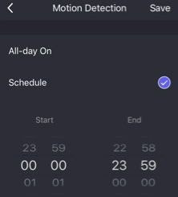 | Schedule: All-day on or Schedule for the time that meets your needs

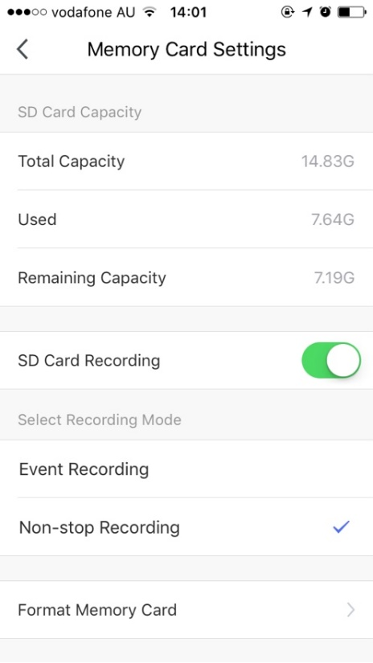 | Memory Card Settings  SD Card Recoding: This option must be turned on if you want to record footage onto SD card and view it in playback mode  Event recording: Only records if it detects movement, motion detection option must be on at same time for it to work  Non-stop Recording: Camera will start to record 24/7, when SD card is full, new footage will automatically overwrite the old footage without end user action  Format Memory card: Delete all content on the SD card and formats the SD card into FAT32 format

We recommend use Scandisk, Verbatim, Kingston, Samsung - Class 10 high speed micro SD for best performance, When use non-stop recording a 32GB card can record up 6 days of footage. Event recording can record up to 4 weeks of footage.
If you are using Telstra NBN or other dual-band router that only have 1 Wi-Fi name, you must disable the 5GHz Wi-Fi in order to make a successful connection and for best overall performance, as MOST smart products in Australia only work on the 2.4Ghz signal.
Q. I am using Telstra NBN, I disabled the 5Ghz and I still cannot get it to pair?
Please try using the Guest Network paring instructions on https://mirabellagenio.net.au/faqs
FAQs
Q. LED indicator light is not blinking red rapidly when turned on
A. power off the camera, wait for 20 sec, then power on, use the reset pin, depress the reset hole(small hole under the micro sd slot) until you hear the “dongdongdong” sound, then release the reset pin, wait for another 10-40sec until the light starts to blink red fast (2 blinks per second)
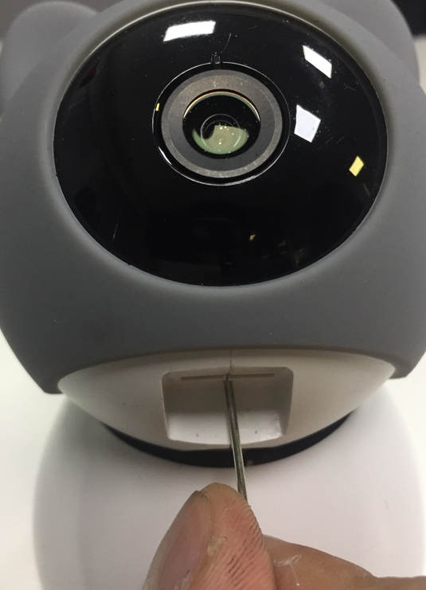
Q. I am using Telstra NBN, I disabled the 5Ghz and I still cannot get it to pair?
Please follow the Guest Network paring instructions on https://mirabellagenio.net.au/faqs
Q. Camera doesn’t scan the QR code and make “dongdongdong” sound
A. Please ensure camera is in the pairing mode,indicator light is blinking red rapidly (2 blinks per second) as per APP screen and not slowly blinking (1 blink per 2 second)
If your camera having difficulty scanning the QR code, please try use alternative SmartConfiguration method, by tapping on Otherwise/Net Pairing Mode -> Select “smartConfiguration” which doesn’t require to scan QR code
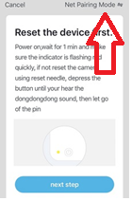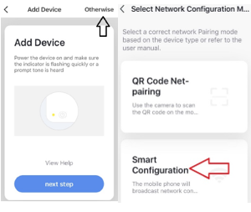
Q. After scanning the QR code, indicator light doesn’t turn into solid blue
A. This is an indication of communication error on the router, please ensure you manually disable the 5GHz Wi-Fi signal on the router setting

Q. How to connect camera to another Wi-Fi network?
A. Go into the cameras settings, tap on “remove device” to remove it and reset the camera and pair it again through the app.

Q. Poor performance, takes a long time to load the live footage?
A. Please check the Wi-Fi signal, if it is a weak signal, you may require moving the camera closer to your router or improvements to your router.

Q. Camera has gone offline and will not reconnect on its own?
A. Go the camera’ settings page, look for “remove device” Remove it and reset the camera and pair it again through the app.

Q. Followed the pairing process but received error cannot find Device?
A. Check the following;
1. 5GHz Wi-Fi signal on the router setting has been disabled
2. Indicator light is blinking red rapidly as per APP screen
3. Please ensure you entered the correct Wi-Fi SSID and password
4. Please ensure phone is on the 2.4GHz Wi-Fi not 4G mobile data or 5GHz
Q. How to turn on or turn off motion detection notifications?
A. 1.On the Genio APP home screen, Tap on Me -> Settings -> Push Notification -> turn on/off Enable notifications
Q. How to change view or arrange device sequences and manage room?
A. In the genio APP home screen, tap on … on the top right corner, to access these options , tap on family name to switch below rooms 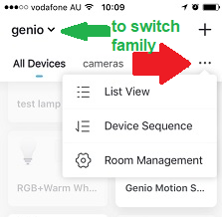
Q. Need more help or further technical assistance from Mirabella engineer?
A. In the genio APP home screen, tap on, Me, -> FAQ & Feedback -> Report issue Fill the fault information or suggest for the APP/product, then submit
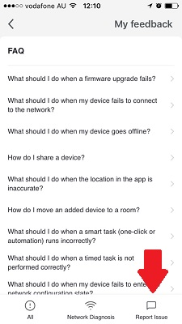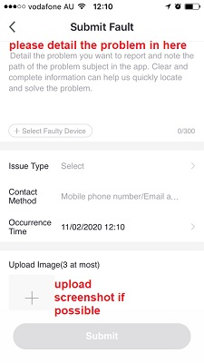
If you have done all of the above, ensuring that the 5Ghz is disabled and the light changed from blinking red to blinking blue, but failed to become a solid blue, then your modem could be incompatible with smart device or it had reached the maximm number of Wi-Fi devices it can handle.

All trademarks are used for reference purposes only. Made in China
MIRABELLA INTERNATIONAL PTY LTD
1 MIRABELLA DRIVE, TULLMARINE, VIC, AUSTRALIA 3043
TOLL FREE: 1800 636 528, www.mirabellagenio.com.au

