Smart Wi-Fi LED STRIPLIGHT INSTRUCTIONS
WARNING:
- LED STRIPLIGHT FOR INDOOR OR OUTDOOR USE
- SAFETY EXTRA LOW VOLTAGE TRANSFORMER MUST REMAIN INDOORS ONLY – IT CANNOT BE EXPOSED TO THE WEATHER
TO ENSURE THE SAFE AND SATISFACTORY OPERATION OF THIS SET PLEASE READ THESE INSTRUCTIONS CAREFULLY AND RETAIN FOR FUTURE REFERENCE
FOR ANY QUESTIONS OR TROUBLESHOOTING PLEASE VISIT www.mirabellagenio.com.au
We recommend that the set be tested prior to being set up in the desired location
SAFETY INFORMATION:-
• Remove set from packaging before connecting to power supply.
• Before using or re-using the set, inspect carefully
• Use only with transformer supplied
• Do not connect set electrically to another set
• Ensure that all of the cable is completely uncoiled whilst set is in use.
Failure to do so may cause over-heating and subsequent malfunction
• Avoid damage to wire insulation (cable), as this could cause a short-circuit and damage the transformer
• Do not use any set which has: – cut, damaged, or frayed wire insulation, cracks in lamp-holders,
loose connections or exposed wires

Note: When connecting the controller to the strip light, please ensure the arrows are aligned with one another
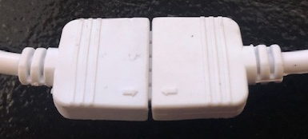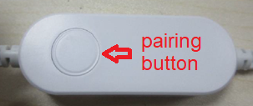

1. Connection Preparation
It is important that your phone is connected to 2.4Ghz Wi-Fi and not the 5GHz,
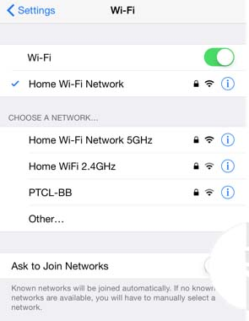
To verify your mobile device is set to a 2.4Ghz Wi-Fi network, Navigate to the Setting menu and click on Wi-Fi. In this menu you will see all detectable networks in your area. Locate the SSID for your network, select a Wi-Fi SSID that doesn’t end with 5G.
Check you have a strong Wi-Fi signal (at least two bars) in the location where the smart device is installed. 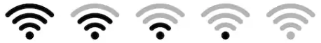
If you don’t have at least two bars signal on your phone, then you may need to reconsider the location or getting a Wi-Fi extender to boost the Wi-Fi signal strength.
Or if you don’t see two SSID’s, one with 5G and one with out 5G, you MUST log into the router and manually disable the 5Ghz Wi-Fi signal if you’re having connection issues, such as connection time out, device is not found error, or device frequently going offline and cannot get back online.
Please contact your internet provider or google how to disable 5Ghz Wi-Fi for your router.

- Install the APP and register Account
For the best experience, download the "Mirabella Genio" APP to your smartphone from App Store or Google Play, the APP icon will be displayed after it’s installed successfully

- Pairing using Mirabella Genio App
Video Tutorials are available on https://mirabellagenio.net.au/led-strip-light
There are two methods to connect your stirp light, if EZ method (fast blinking) doesn’t work, please try use AP method (slowly blinking)
- Connect the light strip then Switch on power at wall, wait a few seconds, strip light will be blinking fast
- If it did not automatically start to blink fast when first powered on, press and hold the paring button on the controller, until the light starts to blink
- Check and verify your mobile phone is connected to 2.4Ghz Wi-Fi network (5Ghz is not supported and must be disabled to avoid confusion on the router setting during pairing)
- Open Mirabella Genio APP, tap on +, then choose from the list
- During the connection 0-100% countdown, strip light will stop blinking., HOWEVER after end of 100% countdown, if the APP display device not found error, this mean the APP failed communicate with our cloud services.
Please re-try using AP method

- While the light is fasting blinking, press and hold the pairing button again, wait for the light start to slowly blinking

- if the fast-blinking method (EZ method, mentioned above) doesn’t work, please try the slow blinking (AP method) below.
While the strip light is rapidly blinking, press and hold the pairing button on the controller wait for the light start to blinking slowly (1 blink per every 2 second)
1. open up the Mirabella genio APP, tap on + , select genio strip light
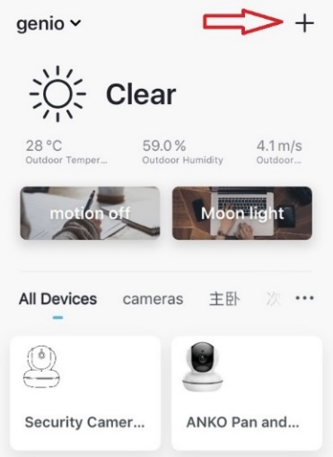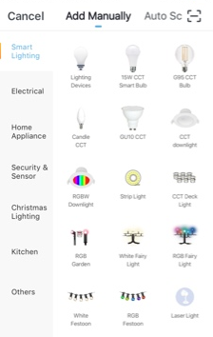
Entre your Wi-Fi name and password, then in reset the device first screen
tap on EZ mode in the Top right hand corner just below the battery image , select AP Mode (refer to the 1st and 2nd image below)
- Now Confirm indicator slowly blinking (refer to image 3), hit Next, then Go to connect and connect to Wi-Fi named SmartLife_XXXX
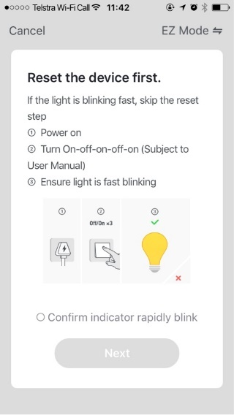 | 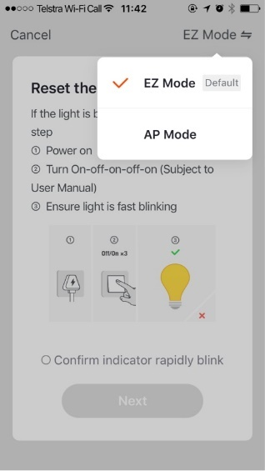 | 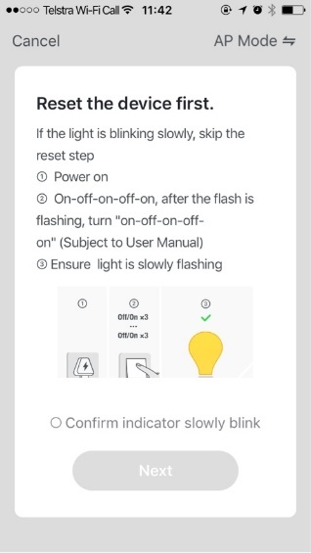
Note: If you fail to see Wi-Fi name beginning with the word SmartLife_XXXX, then mean the device is not slowly blinking,
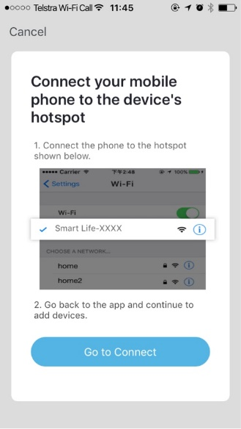 | 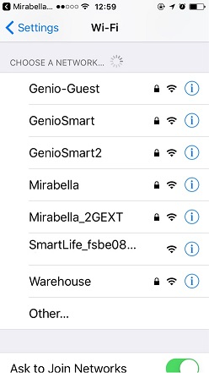 | 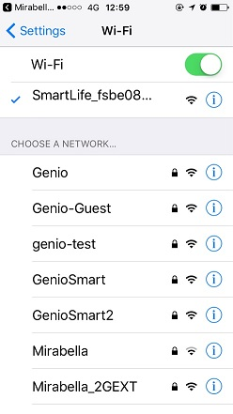
After connected to SmartLife_XXXX, return to Mirabella Genio, APP will commence the 0-100% countdown process
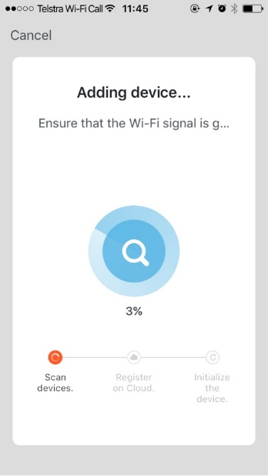 | Please pay attention to the screen to determent the cause of time-out error  If the light never stops blinking, there could be issue with the product itself, please return it  if light does stop blinking, but unable progress to “register on cloud” it indicates communication error with your router to our cloud service (need to check router setting) | please check and ensure  1. You enter the correct 2.4Ghz Wi-Fi name and password  2.Your light is receiving good Wi-Fi signal, and it is not covered by glass or metal shade  3. 5Ghz Wi-Fi signal is turned off on the router

Should the transformer, supply plug or supply flexible cord get damaged, do not attempt to repair.
TO BE REPAIRED BY AN AUTHORIZED PERSON ONLY
THIS IS AN AUSTRALIAN STANDARDS REQUIREMENT IN THE INTEREST OF YOUR SAFETY·

FAQ:
device went offline and doesn’t reconnect back online by itself?
Go the device’ settings page (pencil or ... icon), look for “remove device” Remove it and reset the device and pair it again through the app.

Mirabella International
1 Mirabella Drive
Tullamarine VIC. 3043 Australia
P.O. Box 319, Tullamarine VIC. 3043 Australia
t: 1800 636 528
e: customerservice@mirabella.com.au

