Quick Start Guide
FULL HD Battery Wi-Fi Outdoor Camera
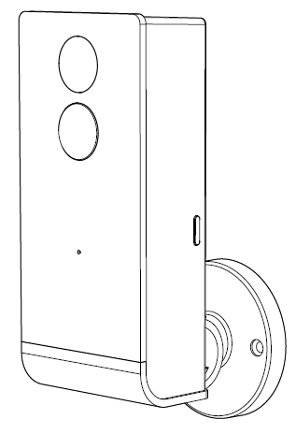
Model: Snap 5S
KEYCODE: 42799351
v.2.0.0 17/09/2020

Welcome, Thank you for choosing our smart camera, getting started is easy
What’s included
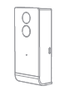 | 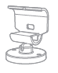 | 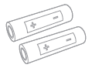 | 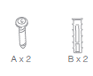
Snap 5S | Bracket | 2 x 18650 Battery | screw set
Product Details
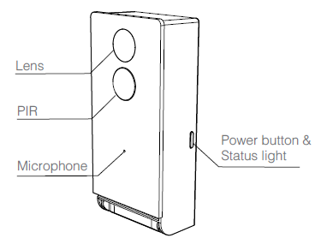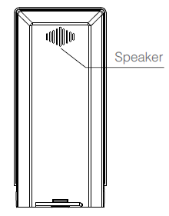
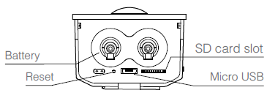

1. Connection Preparation
It is important that your phone is connect to 2.4Ghz Wi-Fi and not to the 5GHz network.
To verify your mobile device is set to a 2.4Ghz Wi-Fi network, navigate to the Settings menu and click on Wi-Fi. In this menu you will see all the detectable networks in your area. Locate the SSID (the name of your network), and ensure that the Wi-Fi SSID does not end with a 5G / 5GHz.

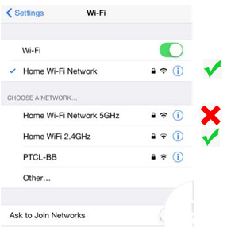

Check you have a strong Wi-Fi signal (at least two bars) in the location where the smart camera is to be installed.
If you don’t have at least two bars signal on your phone, then you may need to reconsider the relocating the camera to a different location or obtain a Wi-Fi extender to boost the Wi-Fi signal strength.

- Install the APP and register Account
For the best experience, download the "Mirabella Genio" APP to your smartphone from the App Store or Google Play, or you can also scan the QR code below, the Genio APP icon will be displayed after it has been installed successfully.
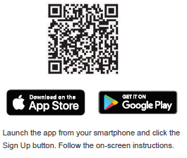
- Insert the Micro SD card (optional, camera will work without it, but it will not able to record any footage)
Open the battery cover, insert the Micro SD card gently into the SD card slot. Please pay attention to the direction of the Micro SD card. Do not force it inside, then close the battery cover.
Micro SD card size needs >8GB, Support up to Max of 128Gb, FAT32 format only, doesn’t support NTFS file system.

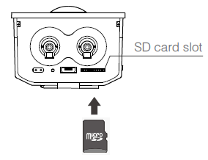

- Camera Installation
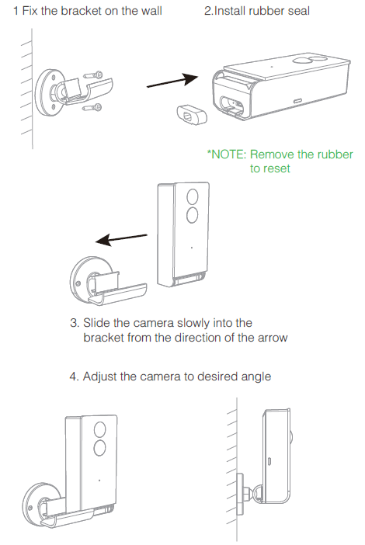

- Pairing the camera using Mirabella Genio App
- Press and hold down the power button, release it when the status light turns red.

- Wait for 6-10 seconds, status light will start blinking RED slowly (1 blink every 2 seconds), now the camera is ready to pair.

If it fails to automatically start blinking RED slowly, or if the LED light is blinking RED fast ( twice blinks per second), then you need to use the reset the unit by depressing the RST reset hole using the pin provided, keep the pin pressed down until you hear a sound, remove the pin. The LED will now start blink RED slowly.

- Check your mobile phone is connected to 2.45Ghz Wi-Fi network (5Ghz is not supported and must be disabled to avoid connection time out on the router setting during pairing)
- Lunch Mirabella Genio APP, tap on +, then choose Security & Sensor , and select your camera from the list
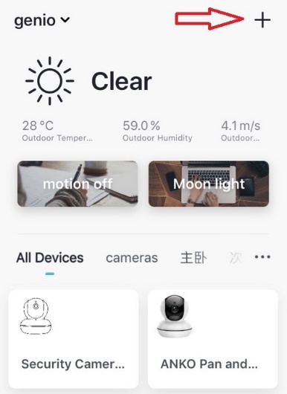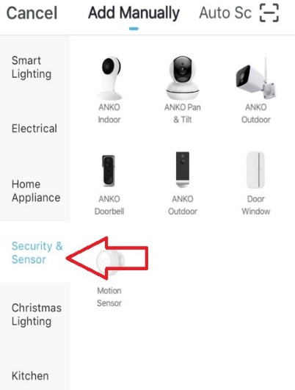
- Follow the APP’s instruction carefully to complete the network pairing process.
- Please wait for indicator light to change to a solid blue colour, then hit the beeped/indicator switch button
video instruction of the whole pairing process also is available on https://mirabellagenio.net.au/battery-camera
If After scanning the QR code, the indicator light has changed from blinking Red to blinking Blue, but failed to become a solid Blue, or you have received the “time out” or “device not found error”, this is an indication of a communication error with your router to our cloud service.
Please ensure
- That you have manually disabled the 5Ghz Wi-Fi signal on your router setting
- The indicator light is still blinking red slowly before stare the pairing process
- Your phone is connected to 2.4Ghz Wi-Fi network, not 4G mobile date or Wi-Fi name end with -5G

If you have done all of the above, ensuring that the 5Ghz is disabled and the light did changed from blinking red to blinking blue, but failed to become a solid blue, then your modem could be incompatible with smart device or router may reach the maximum number of Wi-Fi products it can support/handle.

I am using Telstra NBN, I disabled the 5Ghz and I still cannot get it to pair?
Please follow the Guest Network paring instructions on https://mirabellagenio.net.au/faqs

Note: rechargeable battery can be recharged with supplied USB cable and standard 5V 1A mobile phone USB adaptor (not included)

Camera usage Tips (user interface may change with APP updates)
Tap on the pencil icon or … icon you can access the camera’s Settings page
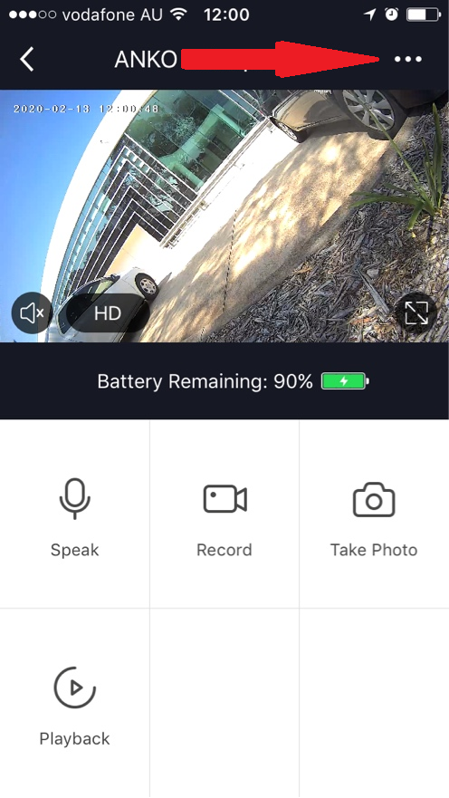 |  | 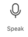 Tap on and speak to your visitor (Two way talk must enable on basic function settings)  Record live footage into your phone’s internal storage  Take screenshots of current live footage  Access the footage recorded on the Micro SD card
To turn sound on/ off
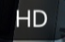To change video quality , high definition or standard definition
To access to camera’s settings page
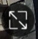To switch to full screen view mode
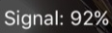: Wi-Fi signal, if signal is less than 60% you should consider changing the location or boost the Wi-Fi Signal using Wi-Fi extender
 | 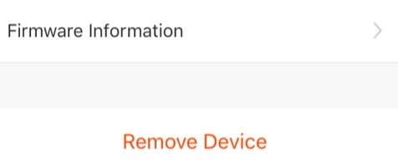 |  | Device Name:  You can customize the camera name here  Share Device, If you wish to share or remove this camera with other genio APP user  Device information: Detail information for this camera, owner information, Virtual ID, IP address etc  Power Management Settings: Set the battery reminder percentage  Basic Function Settings: Please ensure Talk Mode is set as Two Way Talk,  PIR: Motion detection On/off and detection sensitivity level setting, have it off will save your battery life.  Memory Card Settings: This will only appear when 8GB-128GB Micro SD card is inserted  Firmware information: When new firmware is released for this camera you will see this notification icon.  Remove Device: Remove the device from current account so you can re-pair it again or pair under different account
 | 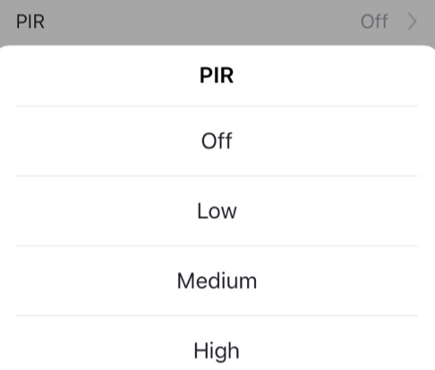 |  | 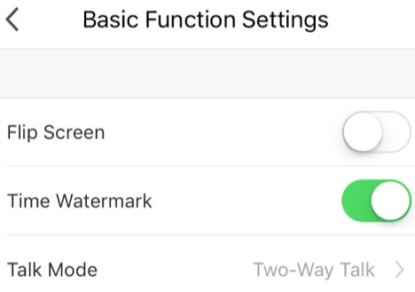
 | We recommend use Scandisk, Verbatim, Kingston , Samsung Class 10 high speed micro SD card for best performance.

Remember the performance of Wi-Fi camera is relies heavily on the performance of your router,
If you are using Telstra NBN or a dual-band router, you must disable the 5GHz Wi-Fi in order to make a successful connection and for best overall performance, as MOST smart products in Australia only work on the 2.4Ghz signal.
FAQ:
How to connect camera to another router?
Go the camera’ settings page, look for “remove device” Remove it and reset the camera and pair it again through the app.

Poor performance, take long time to load the live footage?
Please check the Wi-Fi signal, if it is less than 60%, you will need consider changing the camera location or purchase a Wi-Fi extender to boost the signal.

Camera went offline and doesn’t reconnect back online by itself?
Go the camera’ settings page, look for “remove device” Remove it and reset the camera and pair it again through the app.

Followed the pairing process but still receive the error Cannot find Device?
- Manually disable the 5Ghz Wi-Fi signal on the router setting
- Ensure that the 2.4Ghz Wi-Fi signal is on.
- Ensure the indicator light is blinking RED slowly as per APP screen (1 blink per second)
- Please check you have entered the correct 2.4Ghz Wi-Fi SSID and password

I am using Telstra NBN, I disabled the 5Ghz and I still cannot get it to pair?
Please follow the Guest Network paring instructions on https://mirabellagenio.net.au/faqs
If you have done all of the above, ensuring that the 5Ghz is disabled and the light changed from blinking red to blinking blue, but failed to become a solid blue, then your modem could be incompatible with smart device.

How to turn on or turn off movement notification?
- On the Genio APP home screen, Tap on Me -> Settings -> Push Notification -> turn on/off Enable notifications
- On the iphone, Settings -> Notifications -> turn on/off Allow Notification

For multiple camera setup, change camera view or arrange device set up sequences and manage rooms?
On the genio APP home screen, tap on … on the top right corner, to access these options , tap on V to switch below rooms
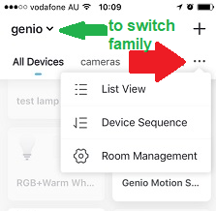
Need more help or need further technical assistant from Mirabella engineer?
On the genio APP home screen, tap on, Me, -> FAQ & Feedback -> Report issue
Fill the fault information or suggest for the APP/product, then submit
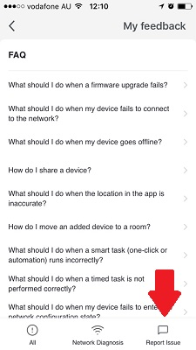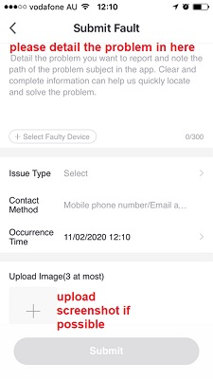
Remember the performance of Wi-Fi camera is relies heavily on the performance of your router, If you are using Telstra NBN or a dual-band router, you must disable the 5GHz Wi-Fi in order to make a successful connection and for best overall performance, as MOST smart products in Australia only work on the 2.4Ghz signal.
All trademarks are used for reference purposes only. Made in China
ANKO, HOME&CO AND AUDIOSONIC® ARE TRADEMARKS OF KMART AUSTRLIA LIMITED.
MIRABELLA INTERNATIONAL PTY LTD
1 MIRABELLA DRIVE, TULLMARINE, VIC, AUSTRALIA 3043
TOLL FREE: 1800 636 528, www.mirabellagenio.com.au
WARNING: Li-ion battery handling notice
Always read the instruction manual and any warnings
on the device before using a lithium-ion battery.
Rechargeable lithium-ion batteries can explode, release
flames, and/or cause burns if disassembled, punctured, cut,
crushed, short-circuited, incinerated, recharged incorrectly,
or exposed to water, fire, or high temperatures.
1.Use the battery charger and AC adapter specified for use
with the lithium-ion battery.
2.Do not force the lithium ion battery into a battery charger or
device if it does not fit.
3.Do not throw lithium-ion batteries into a fire or heat source
also lead to overheating, explosion or fire.
4.Do not connect the positive and negative terminals of the
lithium-ion battery with a metal object.
5.Do not throw lithium-ion batteries, drop them from high
places, or otherwise subject them to strong impacts
6.Do not put a lithium-ion battery in a microwave oven,
pressure container, or other such devices.
7.Do not place combustible materials on top of or over a
lithium-ion battery when charging or discharging.
8.Do not disassemble or modify a lithium-ion battery.
9.When the electric device is not being used for an extended
period of time, remove the lithium-ion batteries from the
device and store them in a dry place.
10.Keep devices that contain batteries and batteries
themselves out of reach of children. Mishandling of
lithium-ion batteries is dangerous.
11.Lithium-ion batteries have finite life spans. If the batteries
require constant recharging, replace them with new ones.
12.If battery leaks or gives off an unusual odour, immediately
remove it and place it away from any naked flame.
13.Never dispose of a lithium-ion battery in your regular trash
or recycling bin, contact your local council for recycling
options

