Quick Start Guide
FULL HD Doorbell Camera
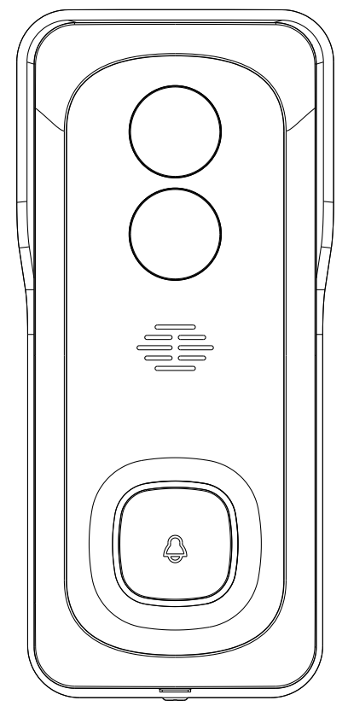
Model:: 42769514 Bell 7S
v3.0 23/11/2020

Welcome, Thank you for choosing our smart camera, getting started is easy
What’s included
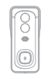 | 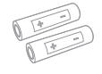 | 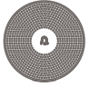 | 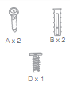
Bell 7S | 2 x 18650 Batteries | USB chime | Wall mount screw sets
Product Details
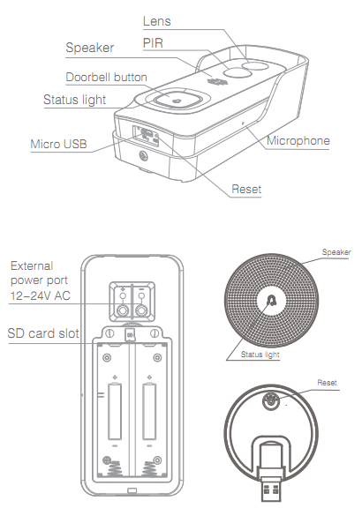
Connection Preparation
It is important that your phone is connect to 2.4Ghz Wi-Fi and not to the 5GHz network.
To verify your mobile device is set to a 2.4Ghz Wi-Fi network, navigate to the Settings menu and click on Wi-Fi. In this menu you will see all the detectable networks in your area. Locate the SSID (the name of your network), and ensure that the Wi-Fi SSID does not end with a 5G / 5GHz.
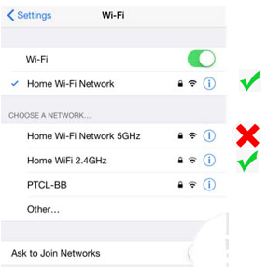

Check you have a strong WI-FI signal (at least two bars) in the location where the smart device is to be installed.
If you don’t have at least two bars signal on your phone, then you may need to reconsider relocating the smart device to a different location or obtain a Wi-Fi extender to boost the WI-FI signal strength.

- Install the APP and register Account
Download the "Mirabella Genio" APP to your smartphone from the App Store or Google Play, or you can also scan the QR code below, the APP icon will be displayed after installed successfully
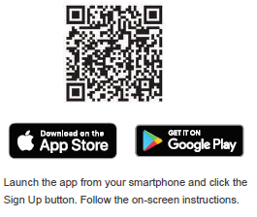
Insert the Micro SD card (not included) The doorbell camera is able to work without a Micro SD card but it will not able to record any footage without a Micro SD card.
Remove the back cover, and carefully insert the Micro SD card in the correct direction, do not force it inside. Then replace the cover.
Micro SD card size needs to be greater than 8GB, Supports up to Max of 128Gb.
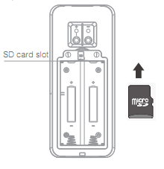
We recommend use Scandisk, Verbatim, Kingston , Samsung Class 10 high speed micro SD for best performance,

- Camera Installation
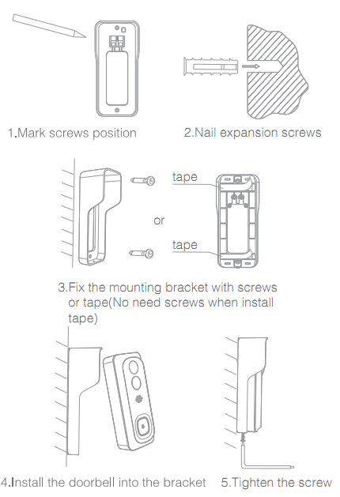
- Pairing the camera using Mirabella Genio App
- Open battery compartment, remove the plastic insulation sheet, Then close the battery compartment cover. If you fail to do so, your door bell will not power on at all.
- Press the doorbell button, wait for 6-30 seconds, the outer ring on the doorbell button will start to blinking red slowly, (1 blink every two seconds)
if it is blinking fast (2 blinks per second) rather than slowly, you will need use the reset pin to depress into the reset hole (RST), keep pressing until you hear a sound, then release the pin. The LED will now start to blink RED slowly.(1 blink every two seconds).

- Please ensure your mobile phone is connected to your 2.4Ghz Wi-Fi network (the smart Wi-Fi doorbell camera is not compatible on 5GHz Wi-Fi network)
- Launch Mirabella Genio APP, tap on +, then choose Security & Sensor
select your doorbell camera from the list of smart camera icon
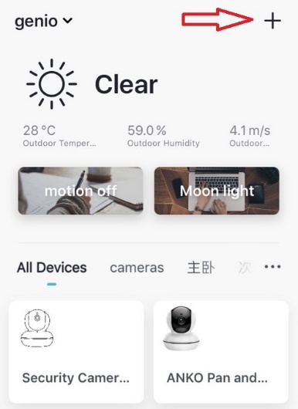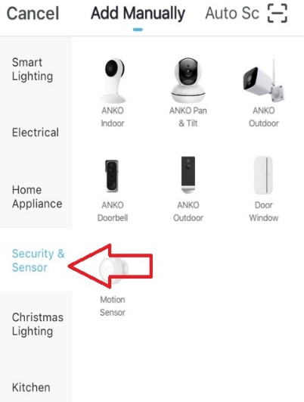
- Double check and ensure that the LED indicator light is still red and blinking slowly, tap confirm blinking slowly and enter your 2.4GHz Wi-Fi name and password
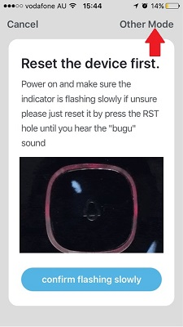 | 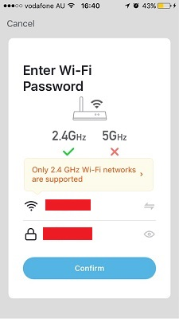
- Tap continue and the QR code will appear, place this QR code in front of the camera at approximate 15-20cm, until your hear a sound, the indicator light will now change from blinking red to blinking blue
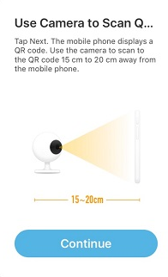 | 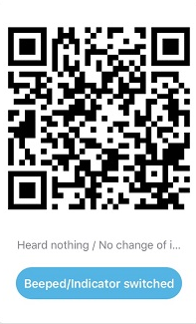
- Please wait for indicator light to switch to solid blue, then tap the beeped/indicator switch button
- Camera is now successfully added into your APP. Please refer to the FAQ section for troubleshooting if this method does not connect.
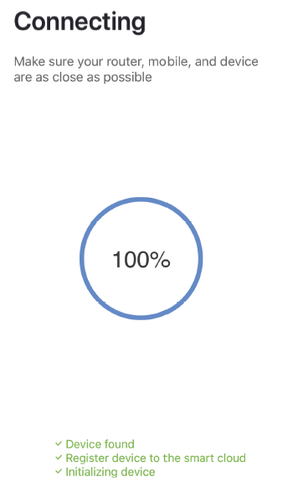 | 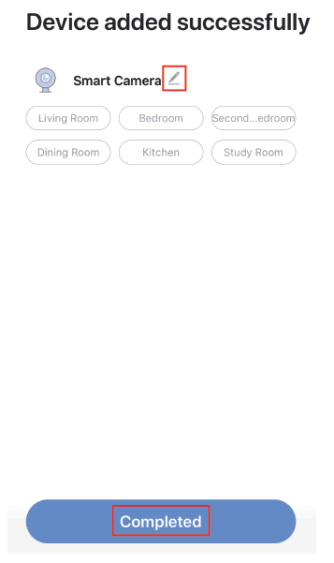
Q. LED indicator is not blinking slowly as per APP screen
A. Power off the camera by removing the battery, wait for 20 sec, then reinsert the battery. Use the reset pin and depress the reset hole until you hear a sound, then release the reset pin, wait for another 30-40 sec until the light starts to blink red slowly (1 blink every two seconds).
Q. Camera doesn’t scan the QR code and make a sound
A. Please ensure camera is in the pairing mode, indicator light is blinking red slowly as per APP screen , if you are unsure, please reset it

Q. After scanning the QR code, indicator light doesn’t turn into solid blue
A. This is an indication of communication error with router, please ensure you have manually disabled the 5GHz Wi-Fi signal on the router setting

Q. I am using Telstra NBN, I disabled the 5Ghz and I still cannot get it to pair?
A. Please follow the Guest Network paring instructions at https://mirabellagenio.net.au/faqs
Note: rechargeable battery can be recharged with supplied USB cable and standard 5V 1A mobile phone USB adaptor (not included)
- Pairing the Wireless Chime
1. Insert the chime into any standard USB outlet or adaptor (not included), the chime needs to be in 5 metres range of the doorbell
2. Open the Mirabella genio APP, tap on doorbell ->setting-> bell setting >choose Wireless Chime or Chime Type , select Wireless Chime
3. Quick press and release the reset button on the back of the chime and ensure the blue indicator light is continuously blinking before adding the chime. If it is not continuously blinking you will need to quick press and release the reset button again before proceeding to step 4
4. Return to setting -> ring setting-> tap on add, If you don’t have ring setting, then go to Bell Setting,-> Bind
5. The indicator light on the chime will stop blinking as soon as you hit the add or Bind, the chime is paired successfully, and you can test it by press the doorbell button.
6. If the chime did not stop blinking, or no ring tone, please unbind the chime, then repeat step 2 to step 5.
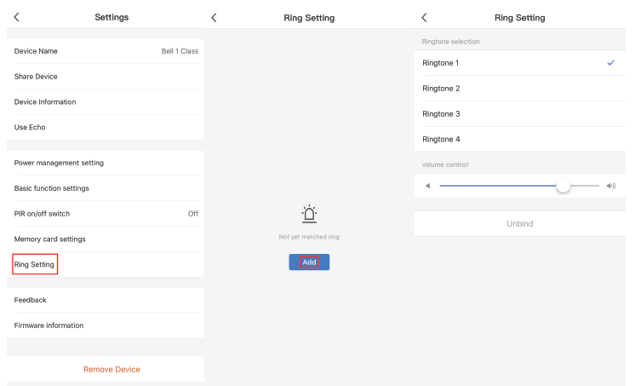
Camera interface is subject to slight alterations based on firmware updates
Tap on the pencil icon or … icon you can access the camera’s Settings page
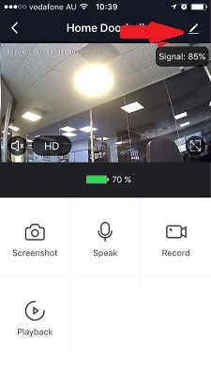 |  |  | To take snapshot of the screen and save it to phone’s camera roll  Tap to speak to the camera  Record live footage into your phone’s internal storage  Access to the footage recorded on the Micro SD card
To turn sound on/ off
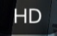To change video quality , high definition or Standard definition
To access to camera’s settings page
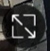To switch to full screen view mode
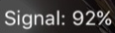: Wi-Fi signal, if signal is less than 60% you should consider changing the location or boost the WI-Fi Signal using Wi-Fi extender
 | 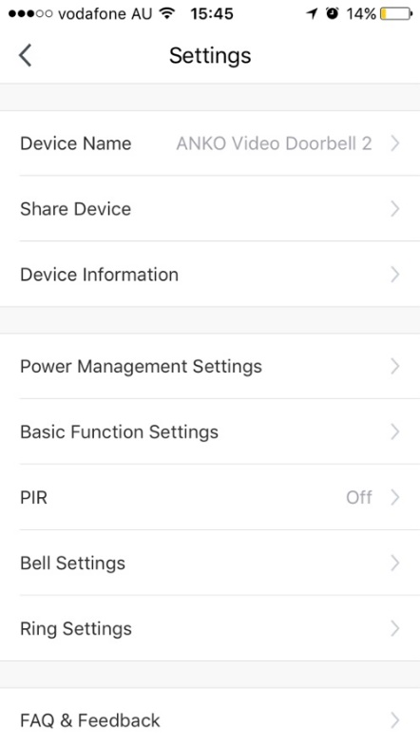  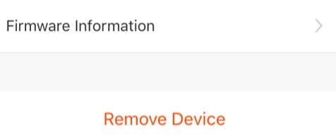 | Device Name: you can customize the doorbell name here  Share Device, if you wish to share or remove this camera with other genio APP user  Device information: detail information for this camera, owner information, Virtual ID, IP address etc  Power Management Settings: set the battery reminder percentage  Basic Function Settings: please ensure Talk Mode is set as Two Way Talk,  PIR: motion detection On/off and detection sensitivity level setting, have it off will save your battery life.  Memory Card Settings: this option will only appear when 8GB-128GB FAT32 format Micro SD card is inserted  Bell Settings: wireless for USB chime  Ring Settings: USB chime ring tone selection  Firmware information: when new firmware is release for this camera you will see a notification icon next to it.  Remove Device: remove the device from current account so you can re-pair it again or pair under different account
 | 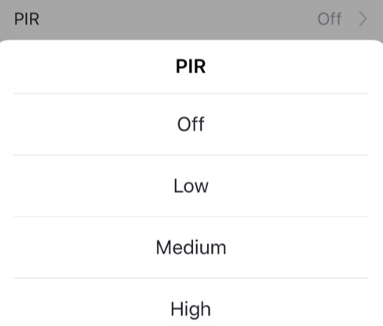 | 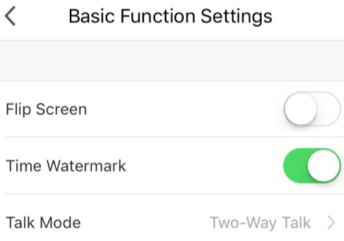

FAQ:
How to connect camera to another router/genio account?
Go the camera’ settings page, look for “remove device” Remove it and reset the camera and pair it again through the APP.

Poor performance, takes a long time to load the live footage?
Please check the Wi-Fi signal, if it is less than 60%, you will need consider changing the camera location or purchase a Wi-Fi extender to boost the signal.

Camera goes offline and doesn’t reconnect back?
Go the camera’ settings page, look for “remove device” Remove it and reset the camera and pair it again through the APP.

Still receive the Cannot find Device error?
Manually disable the 5Ghz Wi-Fi signal on the router setting
Ensure that the 2.4Ghz Wi-Fi signal is on.
Ensure the indicator light is blinking RED rapidly as per APP screen (2 blinks per second)
Please check you have entered the correct 2.4Ghz Wi-Fi SSID and password
How to turn on or turn off notifications?
On the Genio APP home screen, Tap on Me -> Settings -> Push Notification -> turn on/off Enable notifications
How to change view or arrange device sequences and manage room?
A. In the genio APP home screen, tap on … on the top right corner, to access these options , tap on family name to switch below rooms
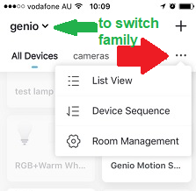
Q. Need more help or further technical assistance from Mirabella engineer?
A. In the genio APP home screen, tap on, Me, -> FAQ & Feedback -> Report issue
Fill the fault information or suggest for the APP/product, then submit
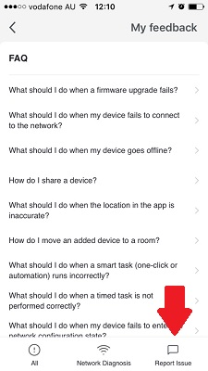 | 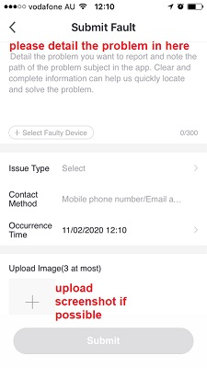
Remember the performance of Wi-Fi camera is relies heavily on the performance of your router, If you are using Telstra NBN or a dual-band router, you must disable the 5GHz Wi-Fi in order to make a successful connection and for best overall performance, as MOST smart products in Australia only work on the 2.4Ghz signal.

All trademarks are used for reference purposes only. Made in China
ANKO, HOME&CO AND AUDIOSONIC® ARE TRADEMARKS OF KMART AUSTRLIA LIMITED.
MIRABELLA INTERNATIONAL PTY LTD
1 MIRABELLA DRIVE, TULLMARINE, VIC, AUSTRALIA 3043
TOLL FREE: 1800 636 528, www.mirabellagenio.com.au

WARNING: Li-ion battery handling notice
Always read the instruction manual and any warnings
on the device before using a lithium-ion battery.
Rechargeable lithium-ion batteries can explode, release
flames, and/or cause burns if disassembled, punctured, cut,
crushed, short-circuited, incinerated, recharged incorrectly,
or exposed to water, fire, or high temperatures.
1.Use the battery charger and AC adapter specified for use
with the lithium-ion battery.
2.Do not force the lithium ion battery into a battery charger or
device if it does not fit.
3.Do not throw lithium-ion batteries into a fire or heat source
also lead to overheating, explosion or fire.
4.Do not connect the positive and negative terminals of the
lithium-ion battery with a metal object.
5.Do not throw lithium-ion batteries, drop them from high
places, or otherwise subject them to strong impacts
6.Do not put a lithium-ion battery in a microwave oven,
pressure container, or other such devices.
7.Do not place combustible materials on top of or over a
lithium-ion battery when charging or discharging.
8.Do not disassemble or modify a lithium-ion battery.
9.When the electric device is not being used for an extended
period of time, remove the lithium-ion batteries from the
device and store them in a dry place.
10.Keep devices that contain batteries and batteries
themselves out of reach of children. Mishandling of
lithium-ion batteries is dangerous.
11.Lithium-ion batteries have finite life spans. If the batteries
require constant recharging, replace them with new ones.
12.If battery leaks or gives off an unusual odour, immediately
remove it and place it away from any naked flame.
13.Never dispose of a lithium-ion battery in your regular trash
or recycling bin, contact your local council for recycling
options

